**HealthHub**

Health Literacy and Awareness Website

Team 5

April 21st, 2025

**Many individuals face barriers in understanding healthcare options, navigating insurance, and locating nearby providers. These challenges are especially prominent in rural Ohio, where provider shortages, financial hardship and low health literacy contribute to delayed treatment and worsened health outcomes. HealthHub is a health literacy and awareness website designed to improve access to care for underserved communities across the United States. The platform presents clear, accessible information on medical services, healthcare terminology, and frequently asked questions, helping users make informed healthcare decisions. It features an interactive map that allows users to search for local providers by specialty and ZIP code, with support for limited internet access through offline fallback dataset. The platform was developed as a progressive web application and integrates the Google Maps API for provider geolocation. To ensure effectiveness, extensive research was conducted on the needs, priorities, and constraints of target populations. Particular attention was given to the sociocultural and infrastructural context of rural Ohio. The project emphasizes sustainability by minimizing environmental impact and reducing operating costs through local data storage and open-source compatibility. By enhancing health literacy and connecting individuals with essential services, HealthHub aims to reduce healthcare disparities and empower users to navigate the medical system with confidence.**

Table of Contents

1. Community Health Needs and Priorities 3

1.1. Detailed View 3

1.2. National Perspective: U.S. Rural Healthcare Challenges 4

1.3. Global Perspective: Healthcare Access and Literacy 5

2. Social and Cultural Context 6

3. Physical Context 7

4. Design Options and Evaluation 8

4.1. Platform Selection 8

4.2. Map Integration 9

4.3. Backend Structure and Offline Capability 11

4.4. Homepage Design Evaluation 12

5. Project Specifications 15

6. Environmental Impact 16

7. Budget and Sustainability Planning 17

8. Final Design Strategy and Rationale 18

9. Implementation and Development Outcomes 19

9.1. Provider Data Strategy and API Pivot 19

9.2. Offline Provider Access: Scope and Limitations 19

9.3. Processing and Filtering Provider Data 19

9.4. Modular Content Delivery 20

10. Conclusion and Future Work 21

References: 22

Appendix A – HealthHub Interface Screenshots 25

A.1. Homepage 25

A.2. Provider Map Page 26

A.3. Terminology Page 28

A.4. FAQ Page 29

A.5. About Us Page 31

Appendix B – Key Code Snippets 32

B.1. Provider Type Filtering 32

B.2. Provider Deduplication Logic 33

B.3. Dynamic FAQ and Terminology Injection 34

B.4. Expandable Card Behavior 35

B.5. Fallback ZIP Code Matching (Offline Search) 36

B.6. Nearby ZIP Retrieval with Fallback 37

B.7. Marker Interaction on Map 37

We developed HealthHub to address significant healthcare access and literacy challenges faced by rural communities, particularly in underserved regions of the United States. Many individuals struggle to understand healthcare options, navigate insurance systems, and identify appropriate providers, barriers that can delay treatment and worsen health outcomes. HealthHub aims to simplify this process by offering a platform that presents clear, accessible information on medical services, healthcare terminology, and frequently asked questions. By improving access to this foundational knowledge, the platform supports individuals in making informed decisions about their care.

To guide the design of HealthHub, targeted research was conducted into the needs, priorities, and constraints of the intended user base. Understanding the specific social, cultural, and infrastructural factors affecting these communities was essential to shaping a solution that is not only functional but also relevant and usable. While this report focuses on rural Ohio, the research process also considered how HealthHub could eventually scale to support similar communities across the country and the globe.

## Community Health Needs and Priorities

### Detailed View

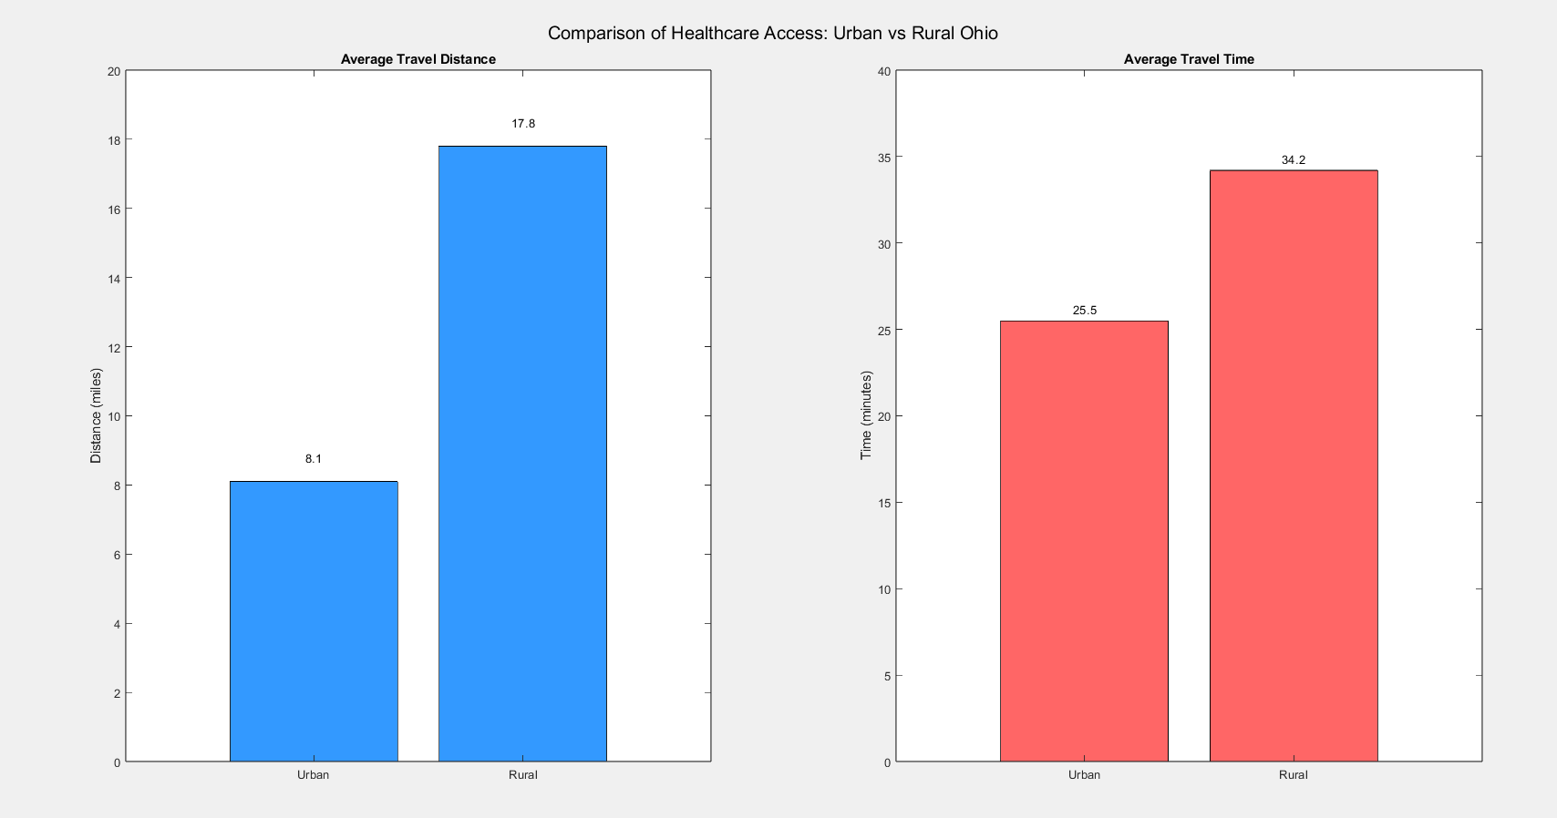People in rural Ohio face significant challenges in accessing healthcare due to a shortage of doctors, dentists, and mental health professionals. Many must travel long distances for care, and some cannot afford medical treatment. As shown in figure 1, these times are vastly different. Although free or low-cost services exist, many residents are unaware of them, leading to delays in treatment. A key solution is to create a software that helps users search for healthcare providers by specialty, location, and cost, making it easier to find the care they need.

Figure 1: Visual comparison of travel distance and time

Rural Ohio includes many small towns and farming communities with limited healthcare services, particularly in Appalachian Ohio, a southeastern region with high poverty rates and few medical facilities [1]. Other rural areas, such as those in the west and north, also struggle due to the closure of small hospitals and clinics, forcing residents to travel long distances for medical care [2]. Because of these challenges, improving access to provider information can significantly help residents receive timely treatment.

Many people in Appalachian Ohio face financial barriers to healthcare, even when free or low-cost services are available [3]. Additionally, a large portion of the population is uninsured or underinsured, further preventing them from seeking necessary medical care. Expanding awareness of financial assistance programs can help more residents access treatment.

Health literacy is another major issue in rural Ohio, especially in Appalachian communities where lower education levels make it difficult to understand medical terms and treatment options [4]. This challenge is even more significant in cultural groups like the Amish, where traditional practices and limited exposure to modern healthcare contribute to low health literacy [5].

### National Perspective: U.S. Rural Healthcare Challenges

The healthcare access crisis in rural America varies significantly by region, with each area facing distinct challenges due to demographics, provider availability, infrastructure, and economic conditions. The overarching issues include limited healthcare facilities, provider shortages, low health literacy, and poor broadband access restricting telehealth options [6]. Addressing these challenges requires a tailored approach that accounts for the specific needs and priorities of different regions to ensure equitable healthcare access and improved health literacy.

In the Northeast, an aging population drives high demand for chronic disease management, yet rural hospitals are scarce, requiring residents to travel long distances for specialized care [7]. Additionally, a decline in primary care physicians further exacerbates access issues. The region’s harsh winters pose additional challenges, impacting emergency response times. To mitigate these issues, the expansion of telehealth services is crucial to connecting patients with specialists, particularly in remote areas. Strengthening local urgent care and mobile health units can enhance immediate care options, while investments in broadband infrastructure will support virtual care services and health education, bridging the gap in healthcare accessibility.

The Midwest presents vast geographic distances that create significant barriers to healthcare access. Chronic conditions such as diabetes and heart disease are prevalent, and the agricultural workforce faces occupational health risks with limited workplace health protections. Additionally, fewer medical students are choosing to practice in rural communities, leading to persistent provider shortages. To address these concerns, incentivizing healthcare professionals to work in rural areas through loan forgiveness programs and increased funding for rural Federally Qualified Health Centers (FQHCs) is essential. Deploying mobile clinics can enhance healthcare reach, while improved emergency medical response systems will ensure timely care for rural residents.

In the South, the highest uninsured rates in the country, coupled with significant rural poverty, severely limit healthcare affordability [7]. High rates of obesity, diabetes, and cardiovascular disease further burden the healthcare system, while health literacy disparities disproportionately impact low-income and minority communities. Medicaid expansion is a necessary step to provide coverage for uninsured individuals and reduce financial barriers to healthcare. Health literacy programs focusing on preventive care and chronic disease management can empower individuals to make informed health decisions. Establishing more Rural Health Clinics (RHCs) and urgent care centers, along with expanding virtual care services in broadband-accessible areas, will improve healthcare accessibility and outcomes [8].

The Western region faces unique challenges, including large Indigenous populations with distinct healthcare needs, severe physician shortages, and difficult terrain that complicates healthcare access. States such as New Mexico, Arizona, and Montana struggle with limited medical providers, while high wildfire and natural disaster risks further strain emergency healthcare responses. Strengthening Indian Health Service (IHS) facilities and forging partnerships with local organizations will be vital to improving healthcare for Indigenous communities. Expanding rural air ambulance services can ensure rapid response to medical emergencies in remote areas. Additionally, leveraging satellite-based telehealth solutions can bridge gaps where traditional broadband infrastructure is lacking, and investing in local medical training programs can help retain healthcare workers in underserved areas.

### Global Perspective: Healthcare Access and Literacy

Globally, access to healthcare and health literacy remains a pressing issue. While urban centers in developed nations have a higher concentration of medical providers and specialists, many rural and underserved areas across the world suffer from a shortage of healthcare professionals, limited hospital facilities, and poor access to specialized care. This problem is compounded by low health literacy rates, making it difficult for individuals to navigate healthcare systems, understand medical terminology, and make informed health decisions. The issue isn’t limited to the United States. Data from the World Health Organization (WHO) indicates that nearly half of the global population lacks access to essential healthcare services. In the U.S., the Department of Health and Human Services (HHS) and the Centers for Disease Control and Prevention (CDC) report that nearly 60 million Americans live in rural areas facing similar healthcare challenges [9]. Many rural counties and developing nations have no local hospitals or specialized medical providers, forcing residents to travel long distances for care. Projections by the Association of American Medical Colleges (AAMC) suggest a shortfall of up to 124,000 physicians by 2034, with rural and underserved communities being the hardest hit [10]. Limited health literacy further exacerbates this situation, as evidenced by the National Assessment of Adult Literacy, which found that more than a third of U.S. adults have difficulty understanding and using health information effectively [11]. In low-income countries, the situation is often worse, with minimal access to health education resources. Even when healthcare resources exist, many rural and low-income populations rely on public healthcare programs that may not cover specialized services or medications, resulting in increased emergency response times and poorer health outcomes. In many parts of the world, lack of internet access further restricts people’s ability to obtain healthcare information and use telehealth services.

Governments and global health organizations, such as the WHO, World Bank, and Health Resources and Services Administration (HRSA), have highlighted several key focus areas for improving healthcare access and literacy. These areas include expanding virtual care options to help mitigate provider shortages in both developed and developing regions, training individuals to educate and guide residents through healthcare processes, and providing accessible information to clarify medical conditions, insurance coverage, and treatment options [12]. They also emphasize the need for investments in mobile clinics, urgent care centers, and training for local healthcare professionals. Collaborative efforts between governments and humanitarian agencies are essential to reaching remote populations and ensuring they receive the care and knowledge they need.

Recognizing the widespread nature of these challenges, our health literacy app can be adapted to address healthcare gaps on national and global scales. One approach is to integrate Federally Qualified Health Centers (FQHCs) and Rural Health Clinics (RHCs) into our mapping feature so that users can locate the nearest care facilities. By adding insurance filtering, individuals can identify providers who accept their coverage—such as Medicaid, Medicare, or equivalents outside the U.S.—easing financial and logistical barriers. The app’s multilingual health literacy tools, including educational modules and symptom checkers, will be tailored to diverse populations, while government and nonprofit partnerships can help maintain an up-to-date healthcare provider database and boost outreach efforts. Moreover, the app will adapt to specific global regions by incorporating culturally relevant health literacy content and region-specific medical resources. In areas where healthcare professionals are scarce, AI-driven diagnostics can offer basic symptom assessments, potentially guiding users toward appropriate care.

## Social and Cultural Context

Understanding the social context is crucial in ensuring the effectiveness and acceptance of the HealthHub software. The social, cultural, and linguistic factors that shape these populations are to be carefully considered in the creation of a relevant and sustainable solution. By truly understanding these factors, the software can be tailored to meet specific needs and overcome potential, thereby enhancing its impact as a tool for positive social change in healthcare.

**Population Makeup**

The population Composition of rural America is mainly white (over 85%), but in recent years there has been an increase in Latinx and minority African American families. It should also be noted that Ohio is one of the states with the largest Amish population in the United States [13]

**Religion, Culture and Health Perceptions**

Religion is a large part of any culture, and as such is crucial to consider when developing a technology to aid any community. For HealthHub, the culture and religion for rural Ohio was examined. Christianity dominates in terms of religion, and church gatherings are the core of community life [13]. There is also a large Amish community which, due to their religious teachings, avoids the use of electricity and modern technology. Due to religious or living environment reasons, psychological disorders are not taken seriously or even ignored [14]. Low health awareness, economic pressure or other reasons also make people only seek medical attention when the condition worsens. Traditional and conservative values, prevalent in the area often mean people are cautious towards government and external intervention. The perspective on technology is more pragmatic, with a lower acceptance of new technologies unless they can directly solve existing problems. Because of the relatively sparse population in the community, the relationships between neighbors are closer, relying on mutual assistance among neighbors, and trust in "outsiders" takes time to establish [15]

**Language**

Rural Americans mainly speak in English, but there are also Spanish speakers. Amish people may use “Pennsylvania Dutch” as daily language. [13]

**Barriers to Engagement and Access**

Working to aid this population prevents several challenges or limitations. The common health problems in rural areas are chronic diseases with high incidence, drug addiction, and psychological illness [15]. However, these diseases cannot be treated in the short term and require long-term medical treatment. It takes too long to see results and they also always ignored them. This makes it difficult for our website to establish trust relationships locally and promote it. Economic pressure will also compound on previous issues which makes the poor avoid seeking medical care [16]. This is due to the high cost that is often associated with it. Since those in the Amish community do not use mobile phones, or even the internet, a modern technology solution cannot be used by them. A website-based healthcare resource would not be applicable in this community.

## Physical Context

Rural Ohio faces significant challenges in healthcare access due to limited broadband infrastructure, transportation barriers, and a shortage of healthcare providers. People in Rural Ohio often have limited access to technology, and those who do typically rely on cellular devices for communication and information. Many of these areas in Ohio experience poor internet connectivity, with some communities relying on outdated DSL networks or lacking broadband access altogether [17]. This digital divide affects the ability of residents to use online health resources, including telehealth services, medical provider directories, and digital health literacy tools [18]. Additionally, unreliable cellular coverage in some regions further limits the feasibility of app-based healthcare solutions. Public libraries and community centers serve as essential digital access points for many rural residents, but inconsistent availability and operating hours create accessibility gaps [19].

Beyond internet access, geographic and weather-related factors also play a role in limiting healthcare availability. Many rural Ohioans live miles away from the nearest hospital or specialized medical provider, leading to long travel times and limited appointment availability [1]. Seasonal weather conditions, such as heavy snowfall and flooding, can make travel even more difficult, further restricting timely medical access [2]. Additionally, rural communities tend to have aging populations, who may face challenges using mobile technology due to low digital literacy or limited smartphone access.

The preceding sections established the social, physical and healthcare-related challenges facing underserved populations, particularly in rural Ohio. These findings shaped the criteria used to evaluate potential design strategies for HealthHub, ensuring that all proposed solutions would remain grounded in the realities of the users and the environments they aim to serve.

## Design Options and Evaluation

### Platform Selection

When designing a digital health literacy platform for rural Americans, a critical decision is whether to develop a mobile application (app) or a web-based platform (website). This choice affects accessibility, usability, cost, and long-term maintenance. Both options have strengths and trade-offs. Selecting the most appropriate solution requires evaluating factors such as user demographics, internet access, and technical constraints.

**Accessibility and User Experience**

Websites are accessible across multiple devices (phones, tablets, desktops) without requiring installation. They are particularly beneficial for users with limited storage space on their devices or those using shared/public computers (e.g., libraries, community centers). Mobile apps often provide a more seamless and responsive user experience, enabling features like offline access, push notifications, and device integrations (e.g., GPS, camera). However, apps require installation and storage space, which may be barriers for some users in rural areas with limited phone storage.

**Internet and Connectivity Considerations**

A website requires continuous internet access, which can be a limitation in rural areas with weak broadband infrastructure. However, progressive web apps (PWAs) can cache content for offline viewing. Native apps can be designed to work offline, allowing users to download necessary health resources and provider information for later access without internet connectivity. This feature is crucial for users in remote areas.

**Development and Maintenance Costs**

Websites are cheaper to develop and maintain since they require only one version that works across all devices via a browser. Updates are immediate and do not require user action. Developing a mobile app is more expensive and time-consuming, especially if aiming for both Android and iOS compatibility. Apps also require frequent updates, which depend on user action to install new versions.

**Security and Privacy**

Websites rely on SSL encryption and secure login portals to protect user data. Since the platform will deal with health information, ensuring HIPAA compliance (if applicable) may require additional safeguards. Apps can store sensitive data locally, reducing security risks from online breaches, but they also need strong encryption measures to protect stored information.

**Scalability and Future Growth**

Easier to scale as new features can be added without requiring users to download updates. Also, search engine discoverability helps users find resources organically. Scaling an app requires constant updates, and user engagement may be hindered if updates are not regularly installed. However, apps have higher engagement rates due to personalized notifications and reminders.

Given the target audience—rural Americans with potential connectivity issues and varying levels of digital literacy—a website is the more viable initial solution. It provides universal accessibility, lower maintenance costs, and does not require installations. However, integrating progressive web app (PWA) features can offer offline functionality and app-like experiences without the high costs associated with native app development. If engagement and usability metrics indicate a strong demand for app-based functionalities (such as offline access and notifications), a future phase could involve developing a lightweight mobile app that enhances the website’s core features.

### Map Integration

Another important factor when building this platform is considering what maps for API to use. The primary goal of the platform is to connect rural Americans with nearby medical providers by displaying an interactive map with location pins, provider specialties, and other relevant details. The focus of this section is to compare different Maps APIs and how effectively they support geospatial functionality, efficient performance, and scalability, while being cost-effective for a class project.

**Design Criteria**

The decision process is determined by considering several key factors:

* Geospatial Accuracy and Coverage -- The chosen map service must deliver precise location tracking so users in rural areas receive accurate locations for medical providers.
* Performance and Responsiveness -- The selected map service must support rapid loading times with limited resources as it will be used in rural settings.
* Advanced Geospatial Computations -- The map service must use algorithms for calculating distances and provide efficient routing functionality.
* Scalability -- The map service must be able to handle a large volume of data and still be responsive.
* Cost Efficiency --The map service must be cost-effective and offer a balance of functionality and price as the project must be sustainable over time.
* Customization and Integration -- The map service must allow for extensive customization to match the project’s requirements.

**Maps API Options**

Google Maps is widely recognized and used for its comprehensive and reliable platform. Google’s extensive global data set ensures high accuracy which is essential for pinpointing rural medical providers. Google Maps also supports essential functions like geocoding, reverse geocoding, and the Haversine formula which allows for extremely accurate distance calculations. Google Maps also supports complex routing algorithms such as Dijkstra’s and A* to deliver users the optimal navigation route. Google Maps also has comprehensive documentation and is leveraged by many people which helps reduce development time and facilitates easier troubleshooting [20].

Mapbox is another popular maps API that is widely used. One of Mapbox’s biggest features is that it’s built on open data and allows for extensive customization options for map styling and user interface design. It also allows for more flexibility in terms of price when compared to Google Maps. But an issue is that Mapbox may require additional setup to integrate advanced geospatial computations which makes it more complicated to implement [21].

OpenStreetMap is easy to use and is also supported extensively. Another important factor is that it’s open-source and free to use. However, it doesn’t provide advanced geospatial mapping, built-in routing, or geocoding [22].

After evaluation of all of the options presented above, Google Maps API emerges as the best fit for the project. Its geospatial accuracy, support for essential mathematical algorithms, and robust routing capabilities make it well-suited for the rural health literacy app that depends on accurately connecting rural users to nearby medical providers.

**Recommendation**

The design evaluation process provided critical insights into the most effective strategies for building an accessible and user-friendly health literacy platform. Through rigorous assessment, the team selected a website due to its balance between engagement and usability. Additionally, the Google Maps API emerged as the preferred mapping solution, offering robust geospatial accuracy and navigation features essential for rural healthcare access. In evaluating the platform’s format, a website-based approach was determined to be the most practical, ensuring broad accessibility while maintaining lower development and maintenance costs. With these design choices established, the next step involves defining the precise technical specifications necessary to implement the platform effectively. The next section focuses on translating these design decisions into functional requirements, ensuring that the system is both scalable and capable of serving its intended audience efficiently.

### Backend Structure and Offline Capability

There is a direct focus on the offline functionality of the application to avoid overhead cost of development and deployment. Hosting a web application can come with high costs and can ultimately lead to the developers to put a price tag on the software. HealthHub aims to make a free platform that requires no payment and no advertisements to fund the online container in which it is hosted. Our approach prioritizes simplicity and accessibility which will allow users to search for providers using a zip code input system.  
**Programming Language and Implementation**

Python was chosen for its ease of use, extensive library support, and cross-platform compatibility. It allows for efficient development when handling JSON data and integrating APIs. For the user interface, Tkinter or PyQt will provide a lightweight and intuitive graphical experience. Using these tools for our front-end will allow for quicker development because they are built directly into Python’s library.  
**Data Storage Management**

The software will store provider details, including name, location, specialization, and contact information, in a JSON file. Updates will be made manually or periodically by developers to ensure accuracy. If the dataset grows significantly, transitioning to SQLite could improve efficiency. An example of how we may store geolocational information in a JSON file may be designed is seen below in Figure 2:

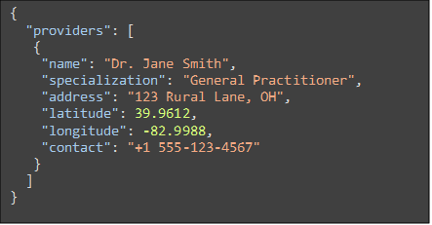

Figure 2: JSON data file example

**User Interface and Features**

The main page will allow users to enter a zip code to find healthcare providers. Locations will appear as pins on an interactive map. Clicking a pin will display provider details, such as specialization and contact information. Mapping functionality will be handled through Google Maps API.  
**Benefits**

This design will guarantee that users can search for providers without internet access while keeping the system lightweight and efficient. Python’s framework simplifies integration with APIs, and Google Maps provides an interactive and user-friendly mapping experience. The single-page UI is accessible to users with varying levels of technical proficiency.

**Challenges and Considerations**

Manual data updates may delay new provider information in local areas. Future iterations could introduce a semi-automated update process. Google Maps API limitations include requiring internet access for initial rendering and potential query rate restrictions. As the dataset expands, moving from JSON to SQLite database may improve performance.

**Recommendation**

The proposed offline application offers a practical solution for assisting rural communities in finding healthcare providers. Using Python, JSON, and Google Maps API ensures a smooth development process and user experience. Future enhancements may include alternative storage solutions and offline-friendly maps like OpenStreetMap. Though the overall structure of this development option is lightweight, the goal is to provide a service that can be created at little to no cost and can allow for any individual to use this resource without a service paywall or advertisements that would help fund the use of containerizing the platform and paying a cost to run the web application year-round.

### Homepage Design Evaluation

The design of a website’s homepage is critical as it is the first point of contact for users of the site and sets the tone for their overall experience. Homepages with good design can not only capture the attention of users but also guide them through the rest of the site effectively. Layout, color scheme, and functionality all contribute to the user’s perception and influence the way they further explore and navigate the site. Additionally, the homepage design has a ripple effect on the rest of the website as well as the project. The design option chosen here has implications for brand identity, user experience, content structure and flow, across both other pages of the website and other materials regarding the project. This section will analyze three options for the homepage design, evaluating their potential impact on the user experience and site performance.

**Design Options**

|  |  |  |
| --- | --- | --- |
|  | Mobile Design | Desktop Design |
| Homepage #1 |  |  |
| Homepage #2 |  |  |
| Homepage #3 |  |  |

**Evaluation Criteria**

Each design will be evaluated on the following 6 criteria. All of which were chosen to ensure the resulting homepage is the best fit for the project and appropriately addresses the needs to the target community.

1. Accessibility (WCAG Compliance): Following Web Content Accessibility Guidelines (WCAG), ensures equal access for all users, even those with visual, auditory, and motor impairments [23], [24].
2. Performance in low-service areas: Website’s function should not be greatly impacted in low-bandwidth environments to accommodate target demographic which have inconsistent internet access [25], [26].
3. Mobile-first design: Homepage design must be optimized for mobile devices, as that is the primary point of access to the internet for many individuals in rural areas [25], [27].
4. Compatibility with older devices: Website should be able to run on older computers as they are often what can be accessed in libraries and community centers [28].
5. Healthcare resource expectations: Design should align with common healthcare website standards and practices to build user trust and familiarity [29].
6. User engagement and readability: Content structure on the website should allow for easy reading and scanning to improve user engagement and comprehension [30].

**Design Evaluation**

Each of the design options were evaluated using the criteria listed above and given a score on a scale of 0 to 5. A score of 5 denotes that the design option fully meets the requirements of the criteria while a score of 0 means the design option fails to meet those requirements. Below is a table which lists the scores of each homepage option in reference to the criteria. The individual scores were also added to create a total score, which is used as a metric to decide the most appropriate choice in homepage design.

|  |  |  |  |
| --- | --- | --- | --- |
| **Design Evaluation of Homepage Options** | | | |
| Design Criteria | Homepage #1 | Homepage #2 | Homepage #3 |
| Accessibility | 5 | 3 | 5 |
| Performance in low-service areas | 5 | 2 | 4 |
| Mobile-First Design | 4 | 2 | 5 |
| Compatibility with Older Devices | 5 | 3 | 5 |
| Healthcare Resource Expectations | 4 | 4 | 5 |
| User Engagement & Readability | 2 | 5 | 5 |
| Total Score | 25/30 | 19/30 | 29/30 |

Each design option had different strengths and were unique in the way they presented the information. Design Option One provided a clear and simple layout, which gives users a very straightforward and direct experience. Option Two prioritized interactivity and user engagement through the introduction of the map. Option Three combines the simplicity of Option One and the interactivity of Option Two to create a layout that users can engage with but is also easy to navigate. This option is well-structured and includes additional content.

**Recommendation**

The option that best aligns with the goals of the project is Design Option Three, which had a score of 29/30. It has an appropriate balance of meeting each criterion while also providing an engaging and useful user experience. Option One, while simple and effective, lacks the engaging elements and additional information found in the other designs, it received a score of 25/30. The points missed for this design were mostly for extreme simplicity and lacking engaging features. The most interactive option is Option Two, however the reliance on a fast and reliable connection means that it does not align with the other needs of the website, which is why it received a 19/30. While Option Three slightly increases the page load time due to additional content and information, the enhanced usability and effectiveness makes it the most appropriate choice.

With the platform’s design decisions established, the next phase involved translating these concepts into actionable specifications and evaluating their broader implications. The following sections outline the technical requirements necessary to implement the proposed solution, assess its environmental sustainability, and estimate its associated costs and funding strategies.

## Project Specifications

To reach the widest audience available, we plan to first launch a website with cache and offline capabilities, as it can be accessed almost anywhere on any connected device, including in rural areas with little to no access to Wi-Fi or cell signals.

HealthHub will include features such as:

1. A map with pins showing medical providers in their area, which can be sorted into different medical specialties, such as dentists, general emergency rooms, chiropractors, physical therapists, and more.
2. Detailed description of each option such as the specialization, address, or other provided services.
3. Explanations of common medical terms.
4. Frequently asked questions (FAQ) page for information on insurance, appointment expectations, and related paperwork.
5. Easy to understand user interface that simplifies the navigational experience.

**Specifics of Website Function:**

1. Using a JSON file, as long as the web-app is able to load initially onto the device, we can allow the website to save the specific locations of local providers. This means the software can still be used from just about anywhere, regardless of signal [31].
2. Offline capabilities would also reduce the load on servers, reducing cost and the need for ads or other funding sources
3. Our web-application will be Python based back end for development.
4. Google Maps API would allow for an easy way to access direction capabilities and allow for user to directly navigate to the desired medical office, as well as physically show providers in the area on a map-based system [20]
5. Lexicon of medical terminology and definitions can be accessed through the terminology page on the website.
6. With an FAQs page, users will be able to find answers to common questions related to healthcare and medical appointments. Here, users will be able to find details about insurance, medical paperwork, and other aspects of healthcare that can be overwhelming.

For most of these features, we can take advantage of hardware already included within the user's device. The web-app can take advantage of the GPS already included with the devices and other pre-installed applications like the Google Maps service, which will allow for a much more cost-effective approach [32].

## Environmental Impact

Resources Used:

* The web app uses Python, which is known for its simplicity and efficiency. This makes it quicker and easier to develop, reducing the energy and resources needed [33]
* Since the software is lightweight and runs offline, it has minimal energy and processing demands. Users can run it on basic personal computers or mobile devices, reducing the need for high-end, power-intensive hardware.
* Provider information is stored in JSON files, which are lightweight and don’t require much storage space. If the amount of data grows, switching to SQLite, which is also efficient, would be beneficial [34]
* The use of Tkinter or PyQt for the app's front end leverages existing Python libraries, minimizing additional resource use.

Pollution During Operation:

* Energy Consumption: Since the web app works offline, it doesn’t need a constant internet connection, saving energy. Using local storage and processing data offline helps lower energy usage compared to apps that rely on cloud services, which are energy intensive.
* Local Storage and Processing: Storing data locally and processing it offline helps lower energy usage compared to cloud-based services.
* API Integration: Google Maps API requires an internet connection for initial setup, but once that’s done, the app's usage is minimal.

Recycling and End-of-Life:

* Software: Software itself doesn’t create physical waste, but the hardware used for development and operation (computers, servers) should be recycled responsibly to minimize environmental impact [35].
* Data Storage: JSON and SQLite databases are digital, so they don’t need physical recycling. The environmental impact is more about the hardware used. It's important to use energy-efficient hardware and follow proper e-waste disposal practices.
* Open-Source Viability: If made open-source, the web application can continue evolving with community support rather than becoming obsolete, reducing the risk of technological waste.

Overall, the proposed offline healthcare resource design is environmentally friendly. By using efficient programming languages and data storage solutions, minimizing the need for internet connectivity, and considering open-source alternatives, the environmental impact is reduced. Future improvements could focus on optimizing energy efficiency and ensuring responsible disposal of hardware.

## Budget and Sustainability Planning

**Cost Estimations**

The cost of creating a web app varies based on scale and complexity. For our project, the cost will breakdown into three main categories: Development, Upkeep, and Disbursement

**Development**

Development costs make up the initial costs of the project and cover the cost of hiring staff, purchasing needed equipment, and designing the product itself. For our project, we can assume there will be no cost for staffing since none of us are being paid to work on this project. Our team plans to utilize the resources available to us through the university to minimize the costs associated with equipment and production software.

**Upkeep**

There will be several long-term costs associated with this project to keep it active:

* The web-app will need to be hosted somewhere either via a dedicated machine or through a web hosting service which ranges in cost from $70-$320.
* Insurance data can be pulled from existing databases that are externally kept up to date [36].
* Large language models (LLMs) or other generative text systems can be used to explain medical terms and provide definitions. The price to use OpenAI’s API, which uses a token-based structure, is (per one million tokens) $5 for inputs, $2.50 for cached inputs, and $20 for outputs. One token is roughly one punctuation character or one word [37].

**Disbursement**

The cost if disbursement refers to the costs associated with marketing the web-app. Marketing costs can vary wildly based on the intended audience, competition, and type of web-app. For our project, the goal of marketing is simply to inform people that our web-app exists and could help them. This can be done virtually for free by utilizing social media, posting fliers in community centers, or reaching out to local leaders to spread awareness about our resource. Working with local churches and outreach programs is expected to be the most effective marketing strategy.

**Funding Sources**

Grants

* There are numerous grants available for health website/app development projects from sources such as the government, foundations or charities, and private organizations.
* From the government, the National Institute of Health (NIH) offers Smart Health Research Grants. The Department of Health and Human Services (DHHS) offers grants for public health initiatives and social service programs [38].
* Other grants include the LEAP in Health IT grant [39], AHRQ Digital Healthcare Solutions grant [40], and the Small Business Innovation Research grant [41].

Donations

* Donations may be capable of covering a significant portion of the upkeep costs. Attending public events and fairs can be useful for both spreading awareness and gathering donations. Another option is through online donation services like Patreon, GoFundMe, Kickstarter, or other crowdfunding services.

## Final Design Strategy and Rationale

The research conducted through this project directly shaped the design strategy for HealthHub. By exploring the needs of the underserved populations in rural Ohio and beyond, the team identified several recurring themes: limited access to nearby healthcare providers, low health literacy levels, financial constraints, and unreliable internet connectivity. These challenges revealed that an effective digital solution would need to be both lightweight and accessible, capable of reaching users across a variety of devices, even in areas with minimal connectivity. It also became clear that the platform must be easy to use, culturally aware, and designed for individuals who may not be familiar with navigating complex healthcare systems.

In response to these needs, four key areas of the platform were evaluated during the design phase. First, the team recommended a progressive-web application (PWA) to ensure compatibility across devices without requiring installation. Second, Google Maps was selected as the mapping tool for its reliable geolocation and smooth mobile integration. Third, a lightweight backend with offline-ready provider data storage was proposed to support users with poor or intermittent connectivity. Lastly, among multiple interface options, Homepage Option 3 was chosen for its clean layout and balanced presentation of core features.

These recommendations formed the foundation for development and were made with careful consideration of the platform’s technical requirements, environmental impact, and cost feasibility, as detailed in preceding sections. The following section outlines how this design was translated into a working platform and where adaptations were made during implementation.

## Implementation and Development Outcomes

The development of HealthHub involved adapting original design goals to practical constraints encountered during implementation. While the website remains faithful to its mission, improving healthcare literacy and access, several aspects of the technical plan evolved in response to data availability, performance needs, and user experience optimization. This section highlights the most notable implementation changes and provides context for those decision. It also confirms the previously outlined design priorities, such as mobile-first layout, responsive user experience, and accessible navigation, were successfully carried through to completion.

### Provider Data Strategy and API Pivot

HealthHub was initially designed to source provider information using the Google Maps Places API. However, during development, it became clear that the Places API lacked sufficient detail for loading provider data regarding specialty, insurance relevance, or facility type. To meet these requirements, the team switched to the NPPES (National Plan and Enumeration System) API, which is provided by the Centers for Medicare & Medicaid Services (CMS). This API offers structured data including taxonomy codes, full addresses, contact details, and facility level metadata. This transition allowed for more accurate and mission-aligned provider listings.

### Offline Provider Access: Scope and Limitations

Offline functionality was a core design priority aimed at supporting users with poor or inconsistent internet access. While the original plan called for preloading all Ohio providers, the full dataset proved too large to include without compromising performance and load speed. Instead, a compromised approach was implemented, balancing offline access and general website functionality. A curated fallback JSON file includes providers only from central Ohio (the current target demographic), ensuring offline access remains possible within a key underserved region. Users can input a ZIP code to view providers from this local file with a matching ZIP code. Due to size limitations, ZIP-radius proximity matching is not available offline. To support broader searches when online, a ZIP code API is used to fetch nearby ZIP codes based on user-entered or geolocated coordinates. This avoids storing thousands of ZIP codes stored locally and reduces unnecessary code overhead.

### Processing and Filtering Provider Data

One important implementation change was the decision to filter and process provider data before displaying it users, rather than showing raw API results. While the NPPES API offered the detailed provider data that HealthHub needed, it also returned a large volume of entries unrelated to primary care or accessible services. These results included suppliers, administrative offices and specialty facilities outside the scope of this project. To ensure clarity and relevance, the team implemented a multi-step filtering process to clean and prioritize the data.

The first layer of filtering used a whitelist of taxonomy codes to include only relevant provider types such as primary care physicians, OB/GYNs, pediatricians, mental health professionals, hospitals, and urgent care clinics. This eliminated noise and focused the search on facilities that the users would realistically visit for general or chronic health needs.

To further streamline the user experience, a deduplication process was implemented to merge provider records that referred to the same organization. Using a name normalization function and geographic proximity check (within 2 miles), entries with similar names and locations were grouped into a single provider card. These merged cards combined specialty information and unified contact details, reducing visual clutter and avoiding confusion. This is the process that prevented the user from seeing multiple doctors working in the same facility or multiple departments of the same clinic as separate entries.

Lastly, to ensure responsive performance and prevent information overload, results were limited to providers within a 30-mile radius of the user’s location or entered ZIP code. A maximum of 20 provider groups are shown per search. This constraint maintains a lightweight, focused, and navigable results interface, especially important in low-bandwidth environments.

This layered filtering strategy enhanced the usability and precision of HealthHub’s provider search, ensuring that users receive information that is both meaningful and manageable.

### Modular Content Delivery

The original plan for delivering health terminology and frequently asked questions was to directly include the content in the HTML pages. However, as development progressed, the team identified a more maintainable and scalable solution: storing this content externally in structured JavaScript-based JSON files and injecting it into the page dynamically using JavaScript. This approach was discussed with usage in provider information, but it was not until development that the use case in these pages was discovered.

This strategy offered several advantages that align with the platform’s goal. First, it provided a clean separation between content and layout, allowing team members to easily update or expand the set of terms of FAQs without needing to modify any HTML. Secondly, the dynamic content loading script ensured that all entries followed a uniform structure and expandable interface, improving both consistency and accessibility. Third, by externalizing the data, the site becomes far more adaptable to future needs, such as supporting multiple languages, organizing by category, or adding a search functionality without overhauling the entire page structure. This change ultimately increased the platform’s flexibility while maintaining its commitment to accessibility and clarity in health education.

**Final Observations**

HealthHub successfully evolved from its original concept into a working, user centered platform that delivers practical healthcare information and provider access tools to underserved communities. While several technical strategies were adjusted – particularly around API capabilities, data volume, and offline storage – these changes enabled a more scalable and maintainable solution. The provider search system now delivers focused, relevant results through custom filtering and intelligent deduplication, while the modular literacy content framework ensures clarity and adaptability for future growth. Most importantly, HealthHub meets its core objectives: empowering users with understandable health information, helping them navigate available care options, and reducing access barriers in rural and low-connectivity regions. These outcomes reinforce the platform’s value as a sustainable model for health equity.

## Conclusion and Future Work

HealthHub represents a step forward in addressing healthcare access and literacy disparities in rural communities. Through thoughtful research, human-centered design, and technical innovation, the project demonstrates how modular, low-cost digital tools can be tailored to meet the needs of underserved populations – even in areas with limited connectivity, digital infrastructure, or health literacy.

The platform’s mobile first layout, offline functionality, and accessible health education tools were intentionally designed to overcome the systemic barriers identified during the research phase. Its integration of provider mapping, modular health content, and a lightweight data framework positions HealthHub as both a practical solution and a salable model for future applications.

Looking ahead, there are several promising directions for expansion and refinement. These include broadening geographic coverage for offline functionality beyond central Ohio, adding multilingual content to serve a more diverse user base, and incorporating advanced features such as specialty filtering, appointment navigation tools, or patient reviews. Establishing partnerships with public health departments, community organizations, or healthcare systems could further enhance data accuracy, outreach, and sustainability.

HealthHub demonstrates how research-informed design and practical development can be combined to address real-world challenges in healthcare access and digital equity. The platform provides a fully functional example of how simple, scalable tools can improve health literacy and connect individuals with essential care resources. While future improvements could enhance its reach and functionality, the current version establishes a strong foundation for accessible, user-centered digital health solutions. HealthHub reinforces the importance of designing with empathy, adaptability, and long-term usability in mind.

### References:

[1] “Rural Ohio faces tough healthcare challenges.” Accessed: Feb. 26, 2025. [Online]. Available: https://www.news5cleveland.com/news/local-news/rural-ohio-faces-tough-healthcare-challenges

[2] “08/16/2024: Graphic of the week: Access to health providers in rural Ohio | News.” Accessed: Feb. 26, 2025. [Online]. Available: https://www.healthpolicyohio.org/health-policy-news/2024/08/16/graphic-of-the-week-access-to-health-providers-in-rural-ohio

[3] K. Morrison, “Cultural & Linguistic Competency for Improved Health Outcomes in Ohio”.

[4] “A Glimpse into Menstrual Health Literacy in Appalachian Ohio.” Accessed: Feb. 26, 2025. [Online]. Available: https://scholarworks.indianapolis.iu.edu/items/89412ade-3962-4ac1-8b15-eb7710529655

[5] “Health Literacy Among the Amish: Measuring a Complex Concept Among a Unique Population - PMC.” Accessed: Feb. 26, 2025. [Online]. Available: https://pmc.ncbi.nlm.nih.gov/articles/PMC3790258/

[6] “Healthcare Access in Rural Communities Overview - Rural Health Information Hub.” Accessed: Mar. 30, 2025. [Online]. Available: https://www.ruralhealthinfo.org/topics/healthcare-access

[7] “Access to Health Care in Rural America: Current Trends and Key Challenges,” ASPE. Accessed: Mar. 30, 2025. [Online]. Available: http://aspe.hhs.gov/reports/health-care-rural-america

[8] “RuralHealthValue.” Accessed: Mar. 30, 2025. [Online]. Available: https://ruralhealthvalue.public-health.uiowa.edu/briefs.html

[9] CDC, “Rural Public Health,” Rural Health. Accessed: Feb. 26, 2025. [Online]. Available: https://www.cdc.gov/rural-health/php/index.html

[10] “Tomorrow’s Doctors, Tomorrow’s Cures | AAMC.” Accessed: Feb. 26, 2025. [Online]. Available: https://www.aamc.org/

[11] “The Health Literacy of America’s Adults: Results from the 2003 National Assessment of Adult Literacy | IES.” Accessed: Feb. 26, 2025. [Online]. Available: https://nces.ed.gov/use-work/resource-library/report/statistical-analysis-report/health-literacy-americas-adults-results-2003-national-assessment-adult-literacy?pubid=2006483

[12] “Rural Health | HRSA.” Accessed: Feb. 26, 2025. [Online]. Available: https://www.hrsa.gov/rural-health

[13] U. C. Bureau, “2020 Decennial Census Data Tables,” Census.gov. Accessed: Feb. 27, 2025. [Online]. Available: https://www.census.gov/programs-surveys/decennial-census/decade/2020/2020-tables.html

[14] “The Amish in Ohio: 2024 Guide (70+ Communities) - Amish America.” Accessed: Feb. 26, 2025. [Online]. Available: https://amishamerica.com/ohio-amish/

[15] O. R. H. Association, “Ohio Rural Health Improvement Plan.” Accessed: Feb. 26, 2025. [Online]. Available: https://www.ohioruralhealth.org/ohio-rural-health-improvement-plan

[16] M. Morrone, N. Kruse, and A. Chadwick, “Environmental and Health Disparities in Appalachian Ohio: Perceptions and Realities,” *J. Health Disparities Res. Pract.*, vol. 7, no. 5, Jan. 2015, [Online]. Available: https://digitalscholarship.unlv.edu/jhdrp/vol7/iss5/5

[17] “Broadband expansion helps rural Ohio residents connect.” Accessed: Feb. 26, 2025. [Online]. Available: https://spectrumnews1.com/oh/columbus/news/2024/11/18/broadband-expansion-helps-rural-residents-connect-

[18] M. Henry, “New report explores barriers to health care access in rural Ohio • Ohio Capital Journal,” Ohio Capital Journal. Accessed: Feb. 26, 2025. [Online]. Available: https://ohiocapitaljournal.com/2024/09/09/new-report-explores-barriers-to-health-care-access-in-rural-ohio/

[19] “08/30/2024: New HPIO data snapshot highlights health challenges in rural, Appalachian Ohio | News.” Accessed: Feb. 26, 2025. [Online]. Available: https://www.healthpolicyohio.org/health-policy-news/2024/08/30/new-hpio-data-snapshot-highlights-health-challenges-in-rural-appalachian-ohio

[20] “Google Maps Platform Documentation,” Google for Developers. Accessed: Feb. 26, 2025. [Online]. Available: https://developers.google.com/maps/documentation

[21] “Mapbox Docs,” Mapbox. Accessed: Feb. 26, 2025. [Online]. Available: https://docs.mapbox.com/

[22] “OpenStreetMap Wiki.” Accessed: Feb. 26, 2025. [Online]. Available: https://wiki.openstreetmap.org/

[23] W. W. A. Initiative (WAI), “WCAG 2 Overview,” Web Accessibility Initiative (WAI). Accessed: Feb. 28, 2025. [Online]. Available: https://www.w3.org/WAI/standards-guidelines/wcag/

[24] “Understanding the Web Content Accessibility Guidelines - Accessibility | MDN.” Accessed: Feb. 28, 2025. [Online]. Available: https://developer.mozilla.org/en-US/docs/Web/Accessibility/Understanding_WCAG

[25] “Designing for Low-Bandwidth Environments.” Accessed: Feb. 28, 2025. [Online]. Available: https://blog.openreplay.com/designing-for-low-bandwidth-environments/

[26] J. M. Graves, D. A. Abshire, S. Amiri, and J. L. Mackelprang, “Disparities in Technology and Broadband Internet Access Across Rurality: Implications for Health and Education,” *Fam. Community Health*, vol. 44, no. 4, p. 257, Dec. 2021, doi: 10.1097/FCH.0000000000000306.

[27] “Mobile-first Indexing Best Practices | Google Search Central | Documentation,” Google for Developers. Accessed: Feb. 28, 2025. [Online]. Available: https://developers.google.com/search/docs/crawling-indexing/mobile/mobile-sites-mobile-first-indexing

[28] “Are Public Computers in Libraries Becoming Obsolete?” Accessed: Feb. 28, 2025. [Online]. Available: https://www.govtech.com/biz/data/are-public-computers-in-libraries-becoming-obsolete

[29] “Journal of Medical Internet Research - Making Quality Health Websites a National Public Health Priority: Toward Quality Standards.” Accessed: Feb. 28, 2025. [Online]. Available: https://www.jmir.org/2016/8/e211/

[30] “Health literacy in rural and urban populations: A systematic review - ScienceDirect.” Accessed: Feb. 28, 2025. [Online]. Available: https://www.sciencedirect.com/science/article/abs/pii/S0738399120303256?via%3Dihub

[31] “JSON File - What is a .json file and how do I open it?” Accessed: Feb. 27, 2025. [Online]. Available: https://fileinfo.com/extension/json

[32] “Google Maps Platform Documentation  |  Places API  |  Google for Developers.” Accessed: Feb. 27, 2025. [Online]. Available: https://developers.google.com/maps/documentation/places/web-service

[33] “Energy Efficiency of programming languages - Revisiting Python in 2024 | green-coding.io.” Accessed: Feb. 07, 2025. [Online]. Available: https://www.green-coding.io/case-studies/energy-efficiency-python/?form=MG0AV3

[34] “About SQLite.” Accessed: Feb. 07, 2025. [Online]. Available: https://www.sqlite.org/about.html

[35] “Electronics Donation and Recycling | US EPA.” Accessed: Feb. 07, 2025. [Online]. Available: https://www.epa.gov/recycle/electronics-donation-and-recycling

[36] “Best Insurance Data Providers & Companies 2025 | Datarade.” Accessed: Mar. 30, 2025. [Online]. Available: https://datarade.ai/data-categories/insurance-data/providers

[37] “Pricing - OpenAI API.” Accessed: Mar. 30, 2025. [Online]. Available: https://platform.openai.com

[38] D. of Grants, “HHS Grants & Contracts.” Accessed: Feb. 28, 2025. [Online]. Available: https://www.hhs.gov/grants-contracts/index.html

[39] “Leading Edge Acceleration Projects (LEAP) in Health Information Technology (Health IT) Notice of Funding Opportunity (NOFO) | HealthIT.gov.” Accessed: Feb. 28, 2025. [Online]. Available: https://www.healthit.gov/topic/onc-funding-opportunities/leading-edge-acceleration-projects-leap-health-information

[40] “AHRQ Digital Healthcare Research Funding Opportunities | Digital Healthcare Research.” Accessed: Feb. 28, 2025. [Online]. Available: https://digital.ahrq.gov/ahrq-digital-healthcare-research-funding-opportunities

[41] “Small Business | Grants & Funding.” Accessed: Feb. 28, 2025. [Online]. Available: https://grants.nih.gov/funding/funding-categories/small-business

# Appendix A – HealthHub Interface Screenshots

## Homepage

* 1. Desktop version

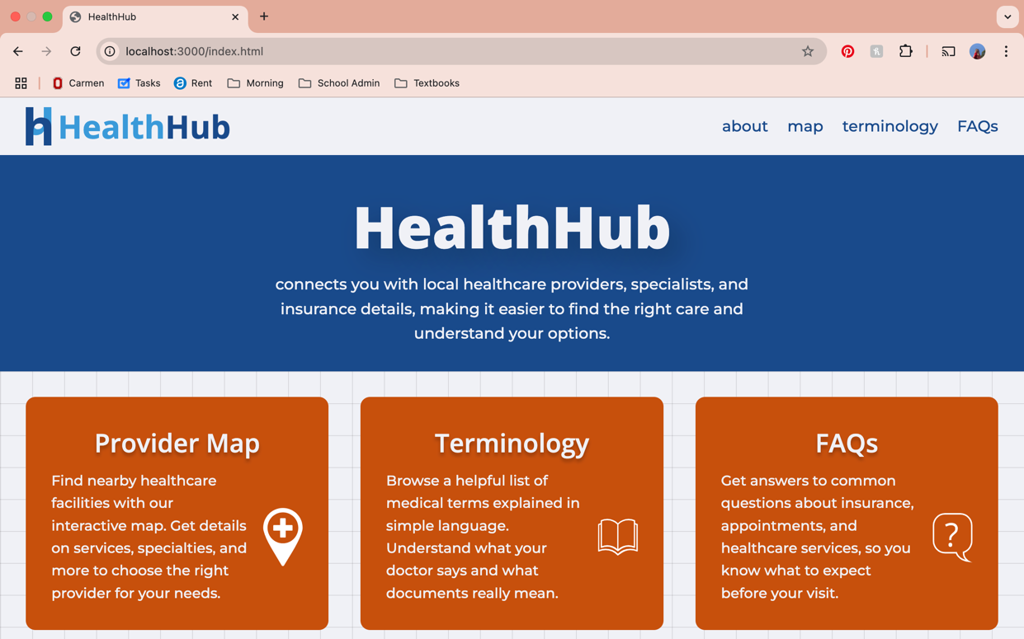

* 1. Mobile version

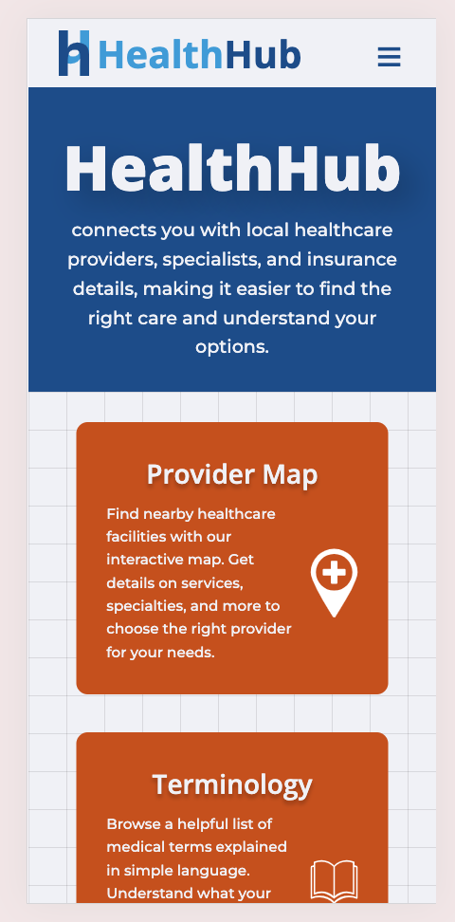 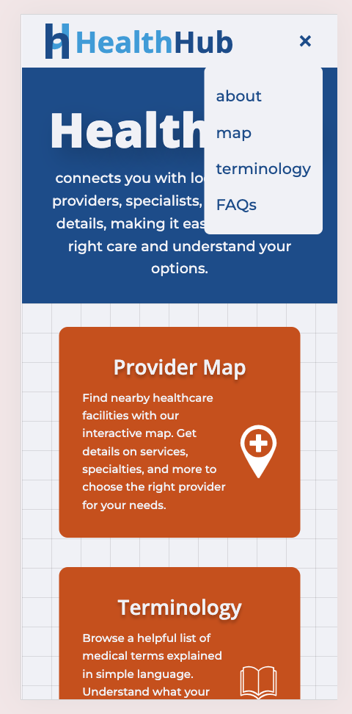

## Provider Map Page

* 1. Desktop – No location Entered

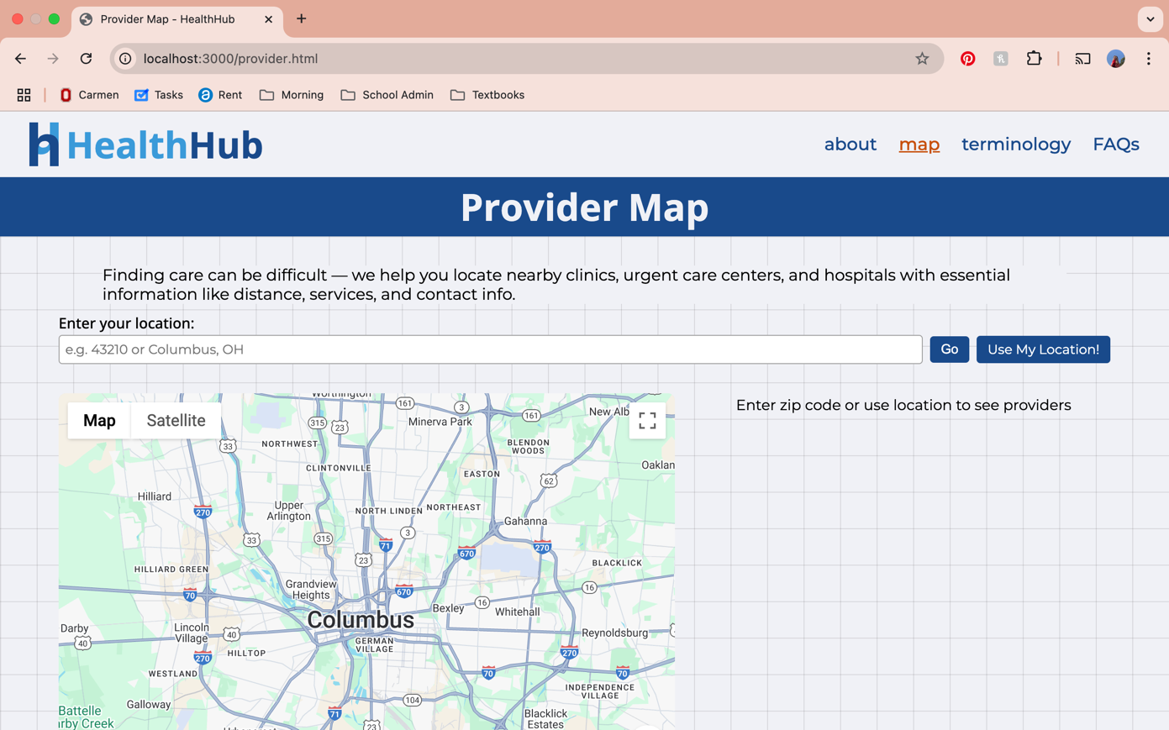

* 1. Desktop – Providers Populated

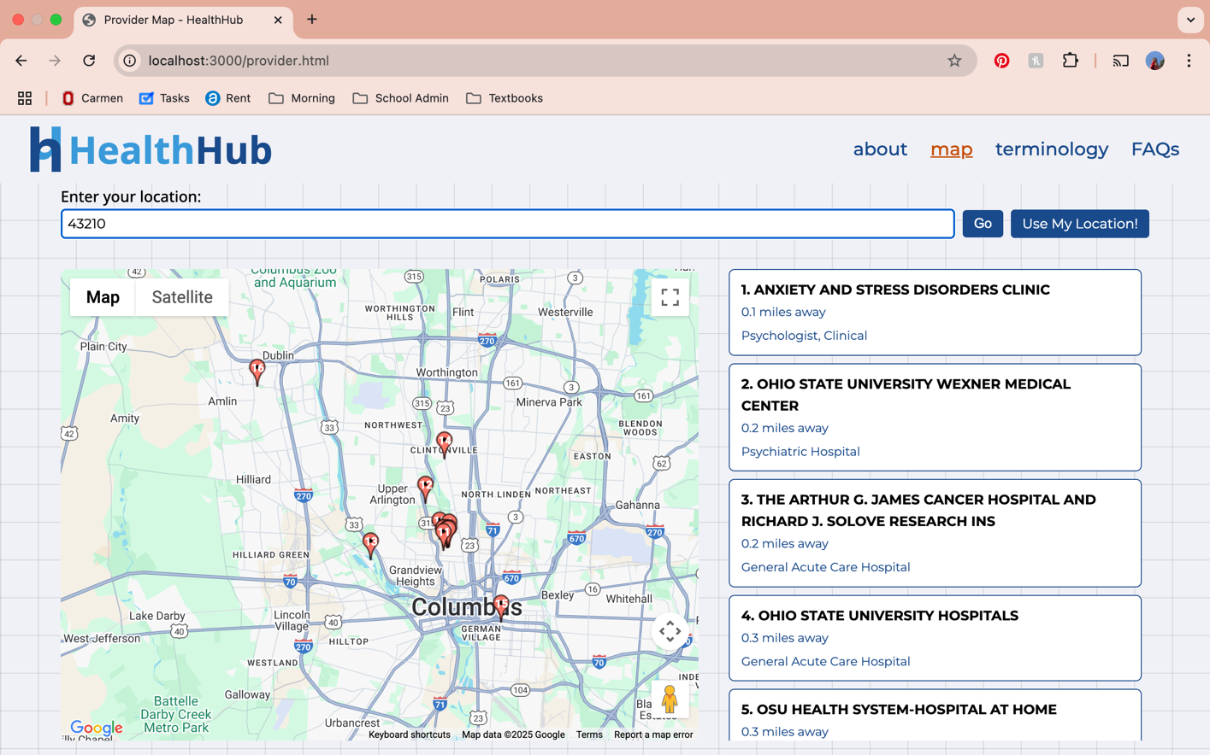

* 1. Desktop – Providers Expanded

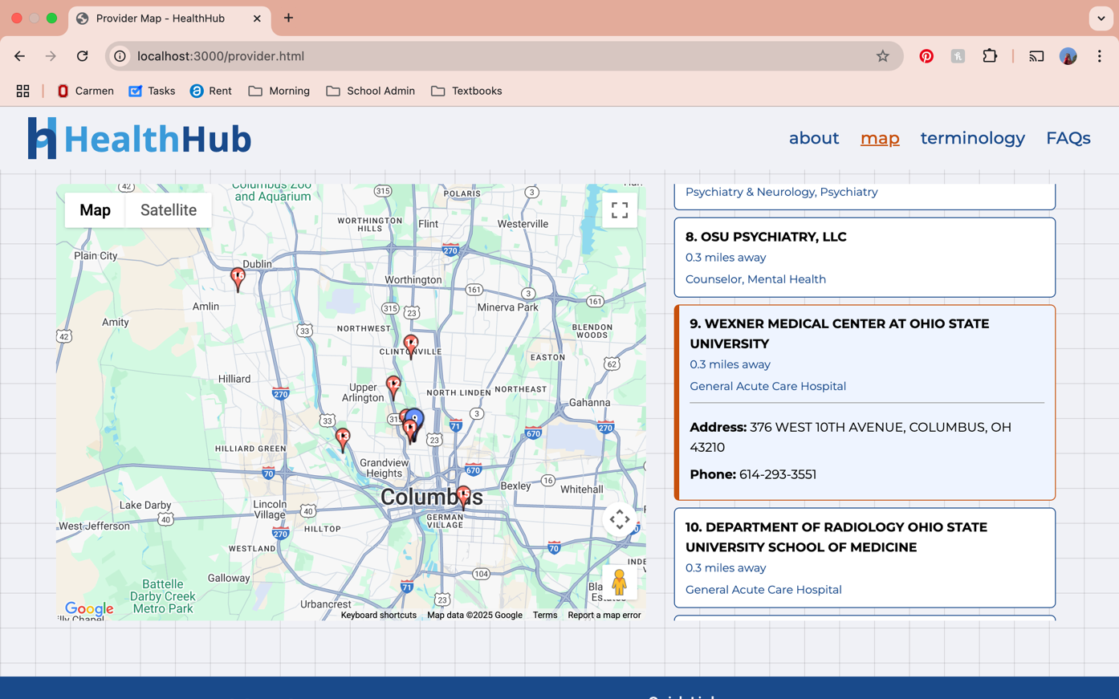

* 1. Mobile – All versions

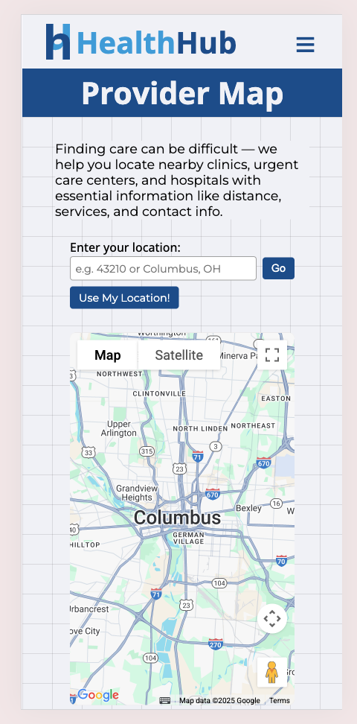 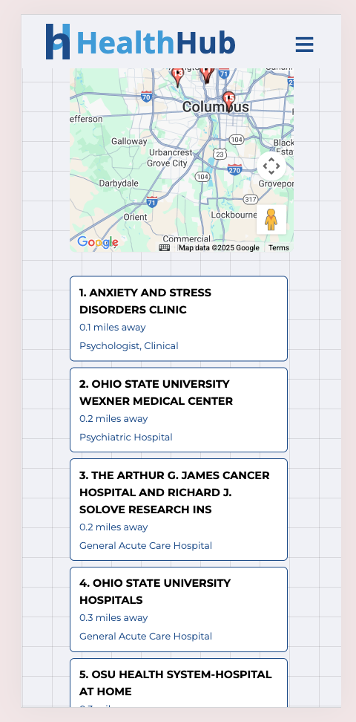 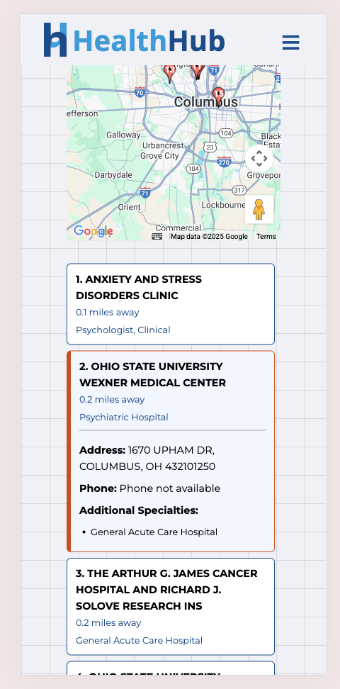

## Terminology Page

* 1. Desktop - Collapsed view

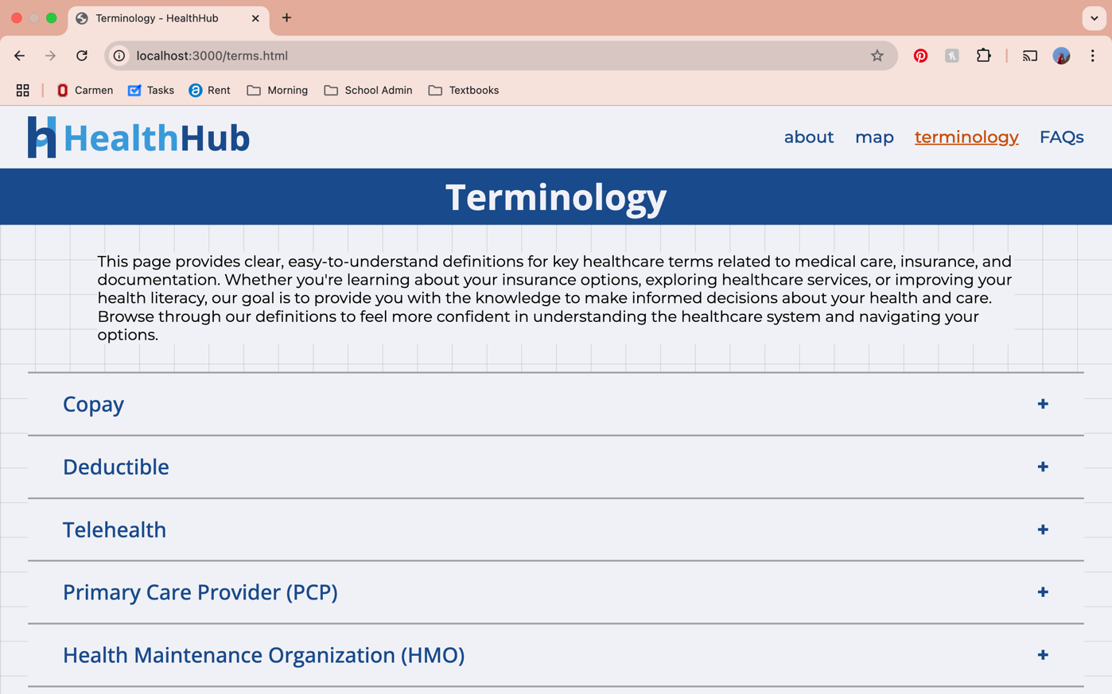

* 1. Desktop – Expanded Term

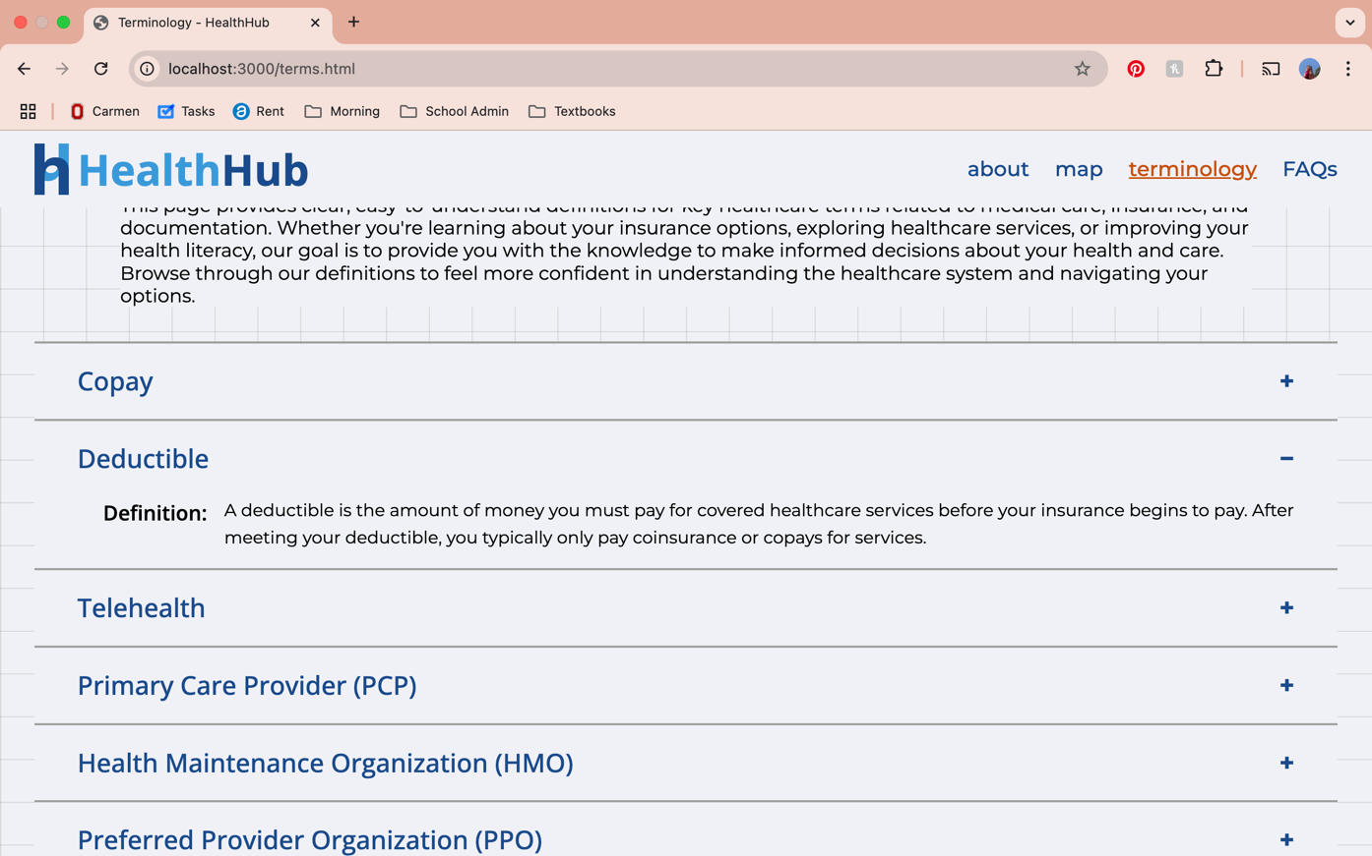

* 1. Mobile – Collapsed and Expanded

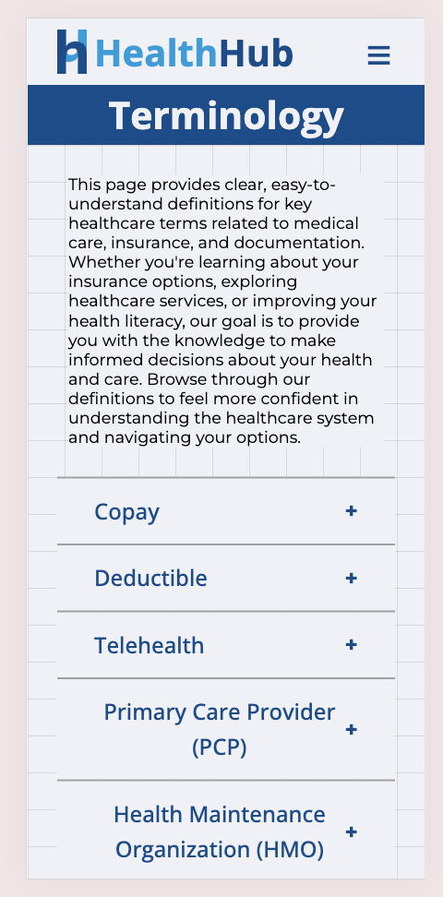 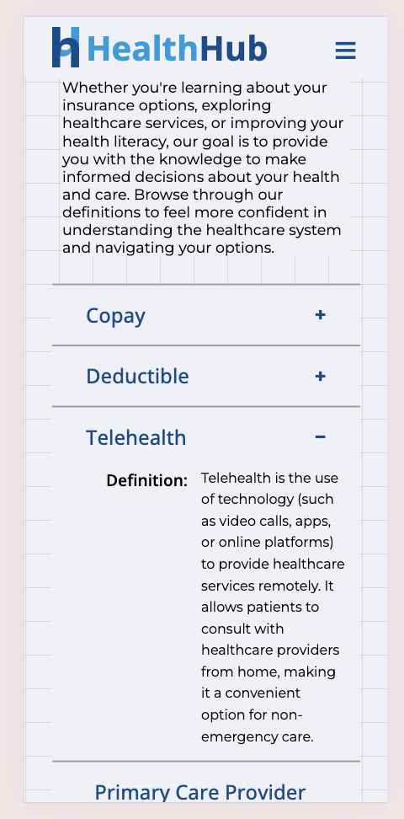

## FAQ Page

* 1. Desktop – Closed FAQ

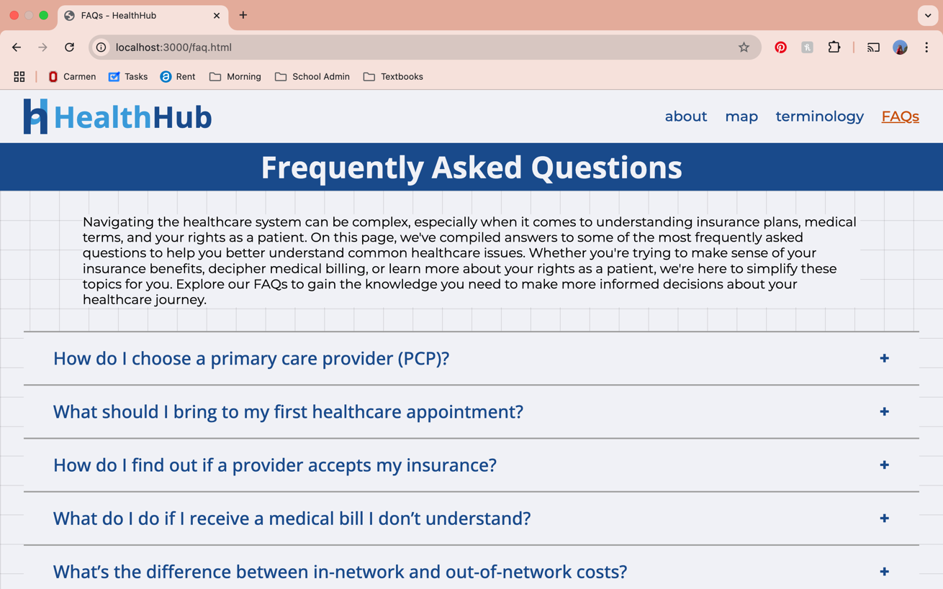

* 1. Desktop – Expanded FAQ

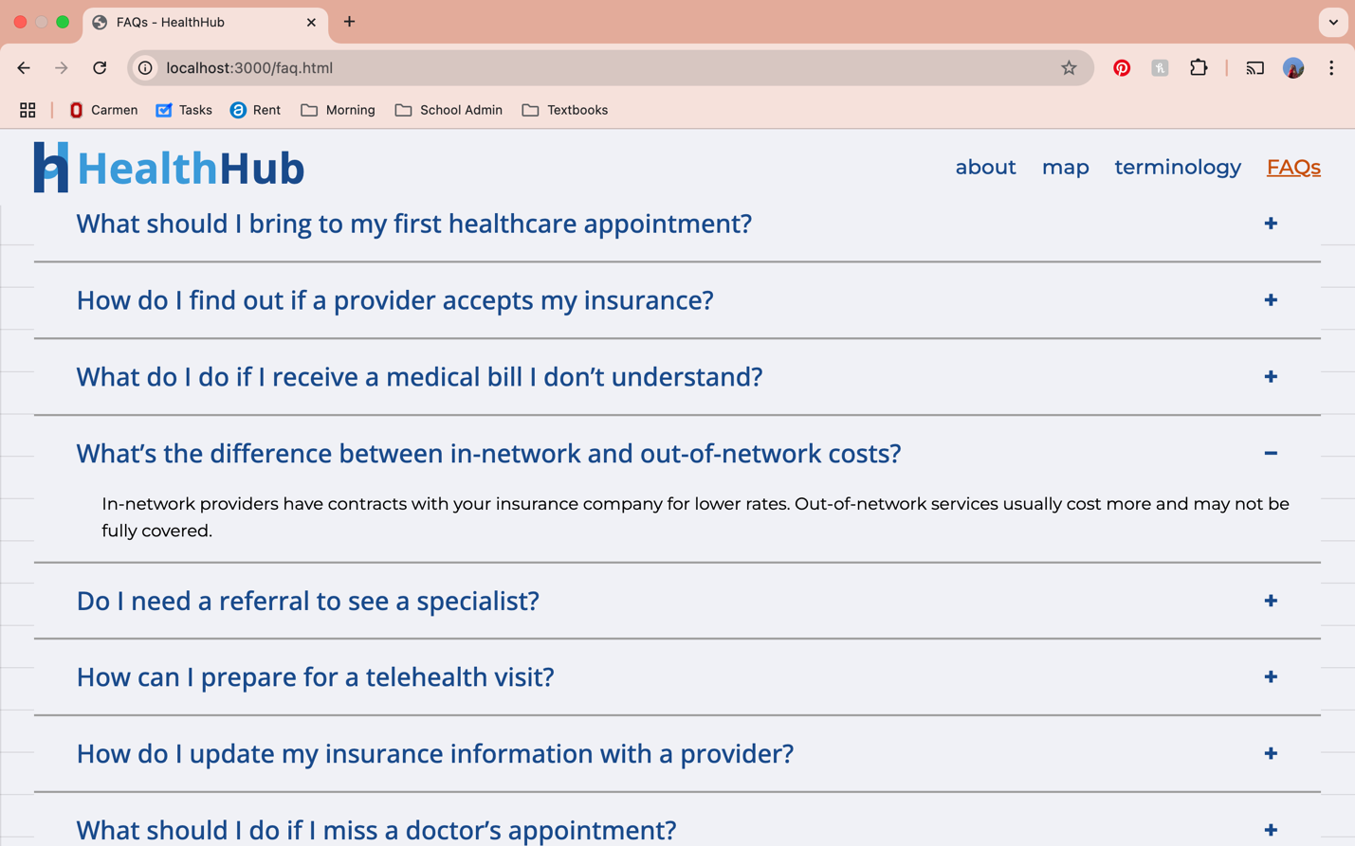

* 1. Mobile – Closed and Expanded FAQ

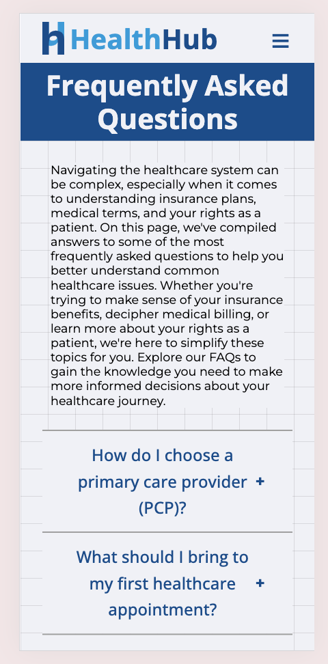 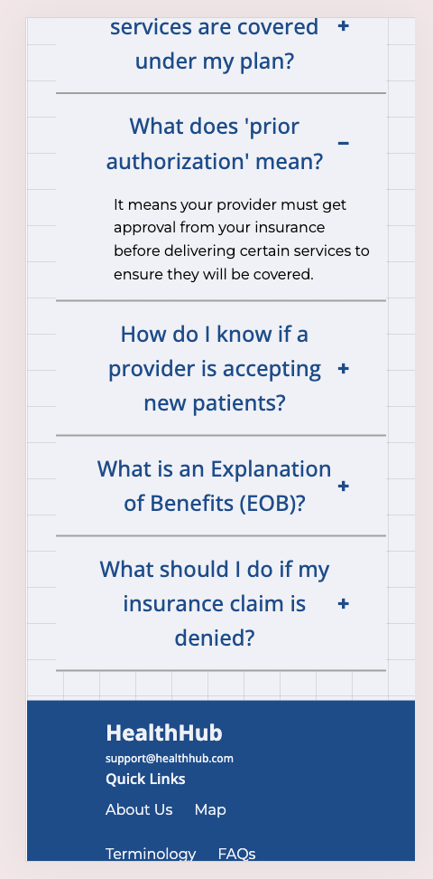

## About Us Page

* 1. Desktop View

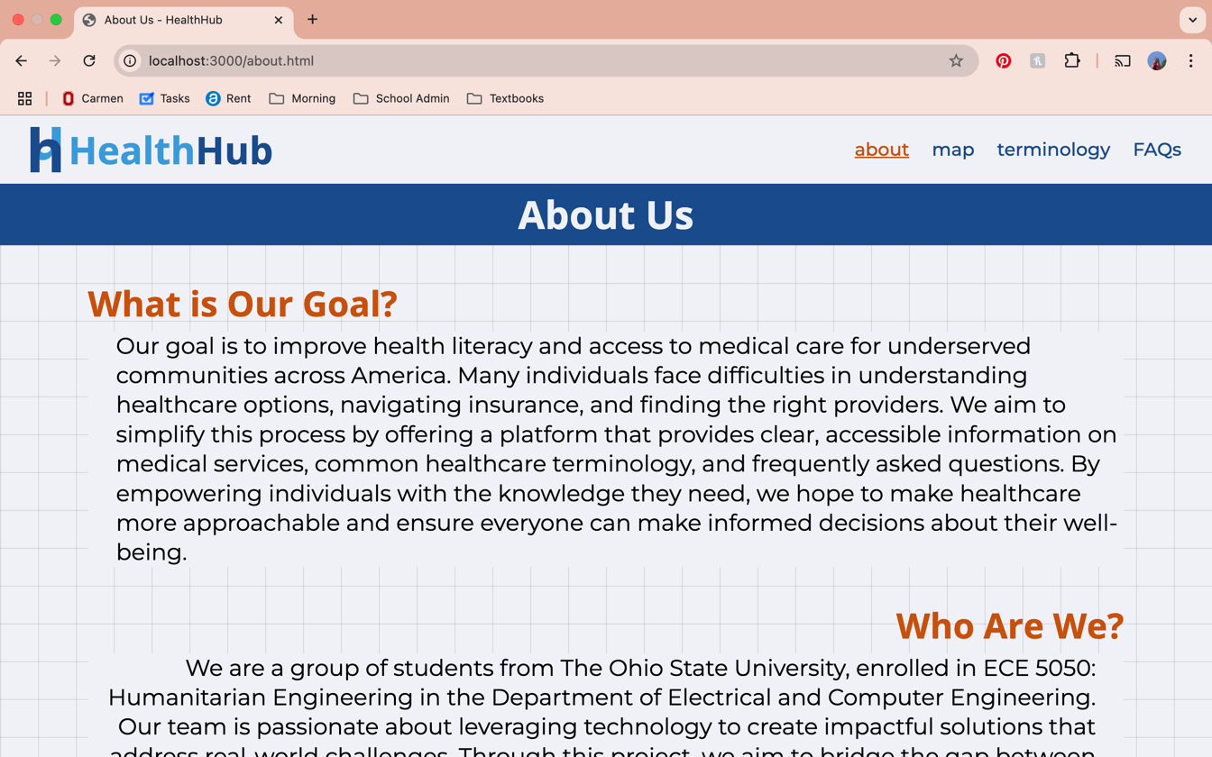

* 1. Mobile View

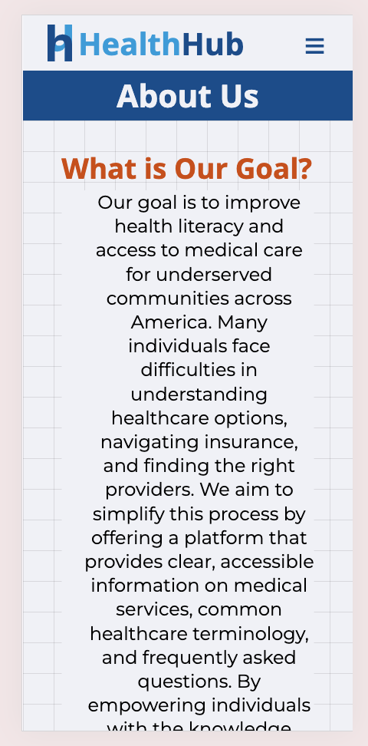 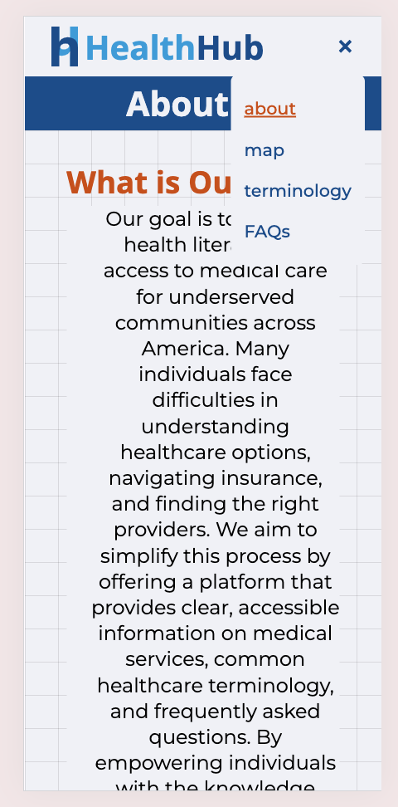

# Appendix B – Key Code Snippets

## Provider Type Filtering

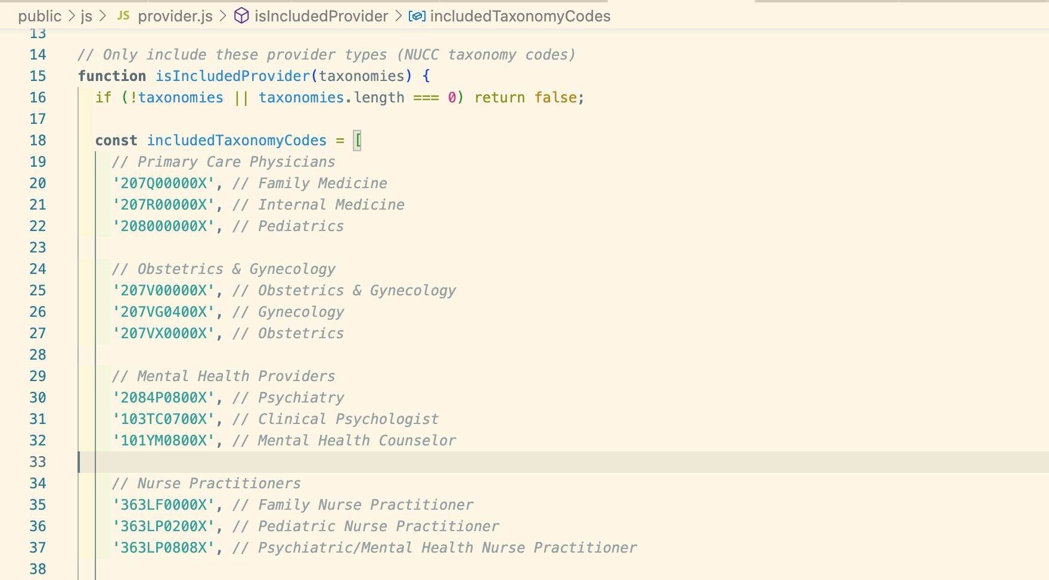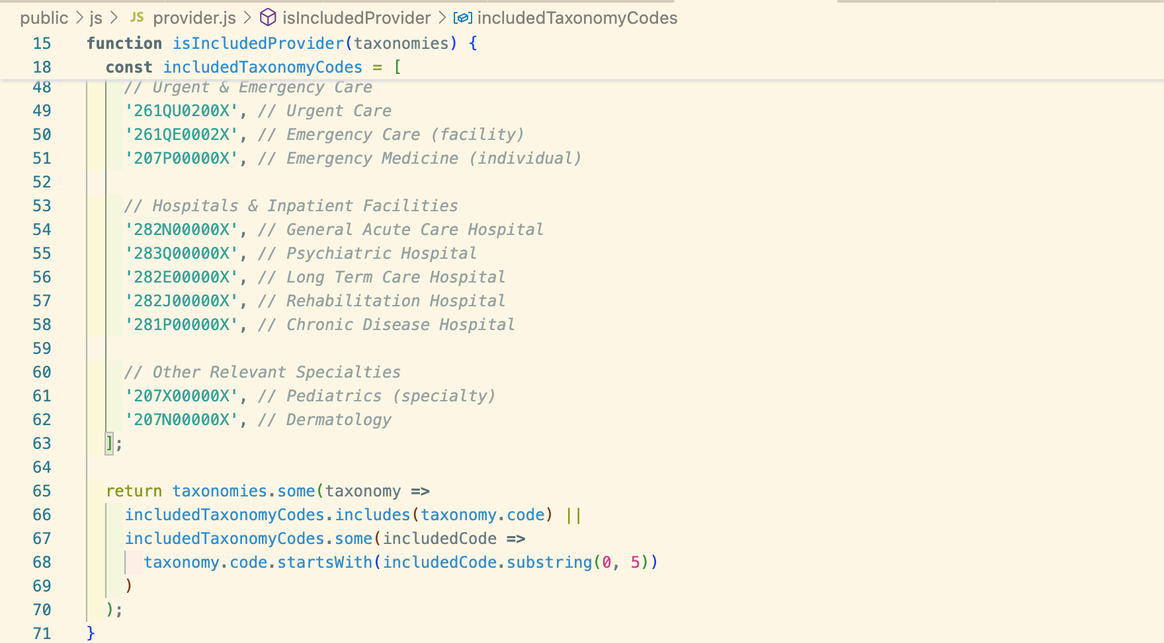

## Provider Deduplication Logic

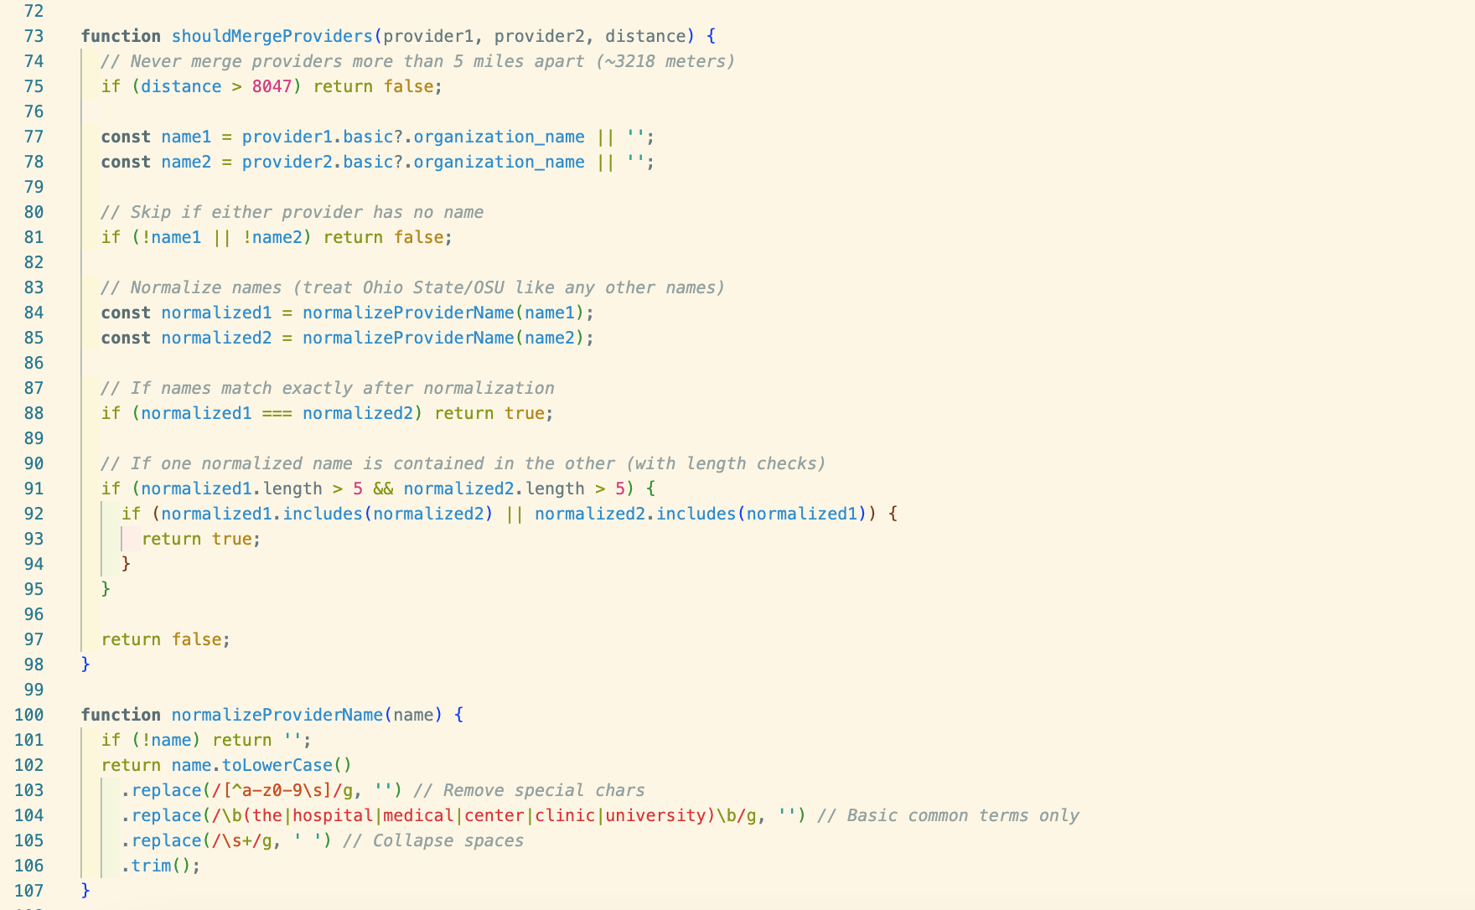

## Dynamic FAQ and Terminology Injection

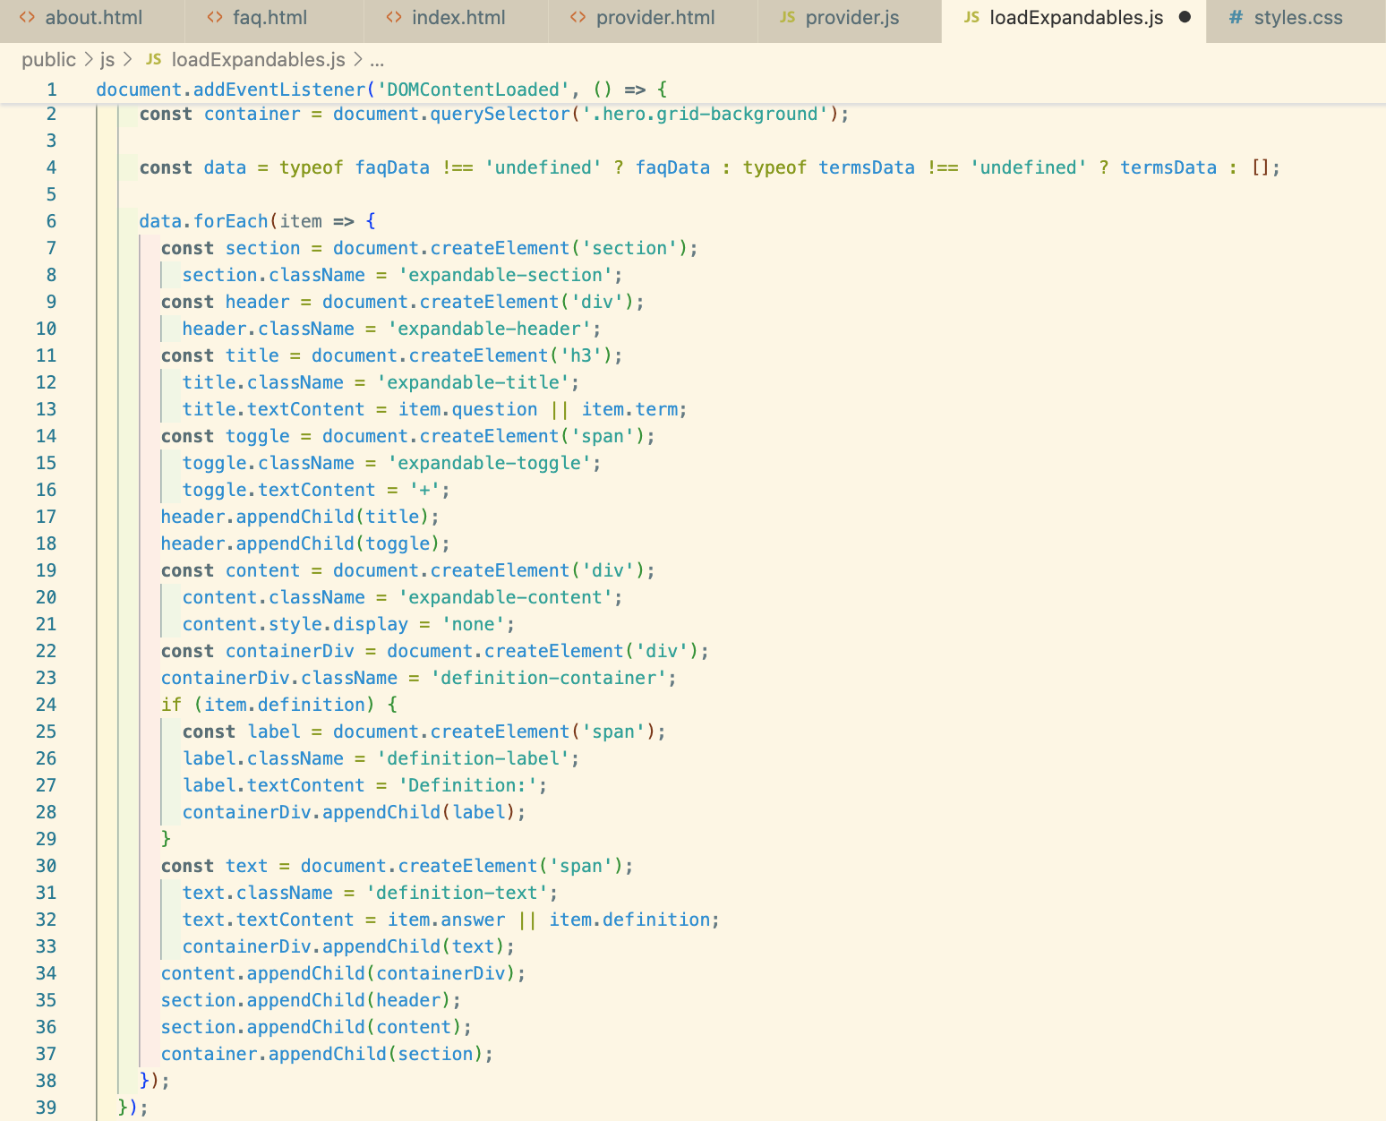

## Expandable Card Behavior

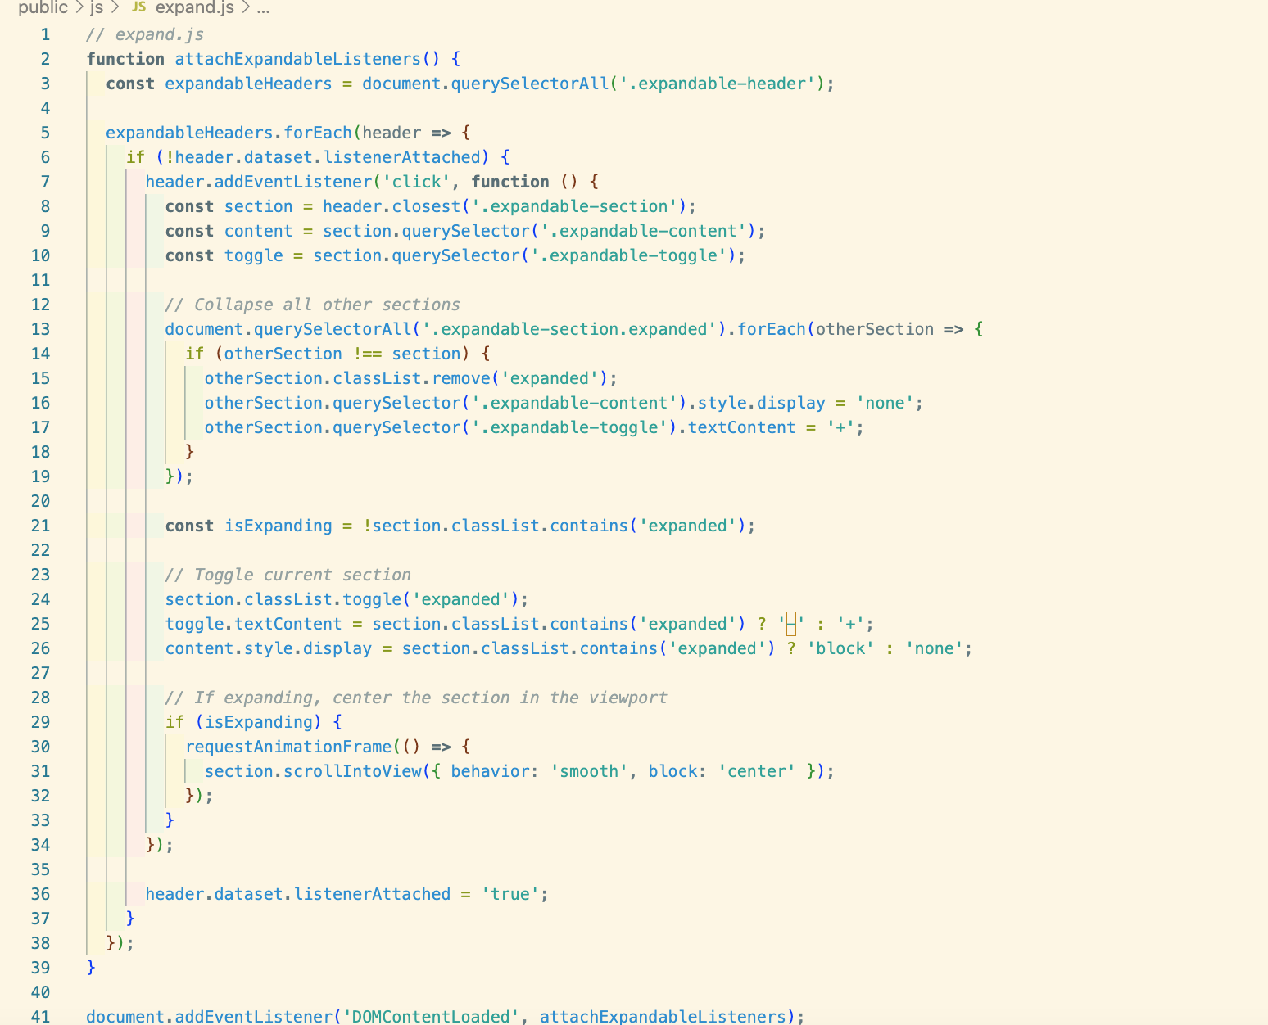

## Fallback ZIP Code Matching (Offline Search)

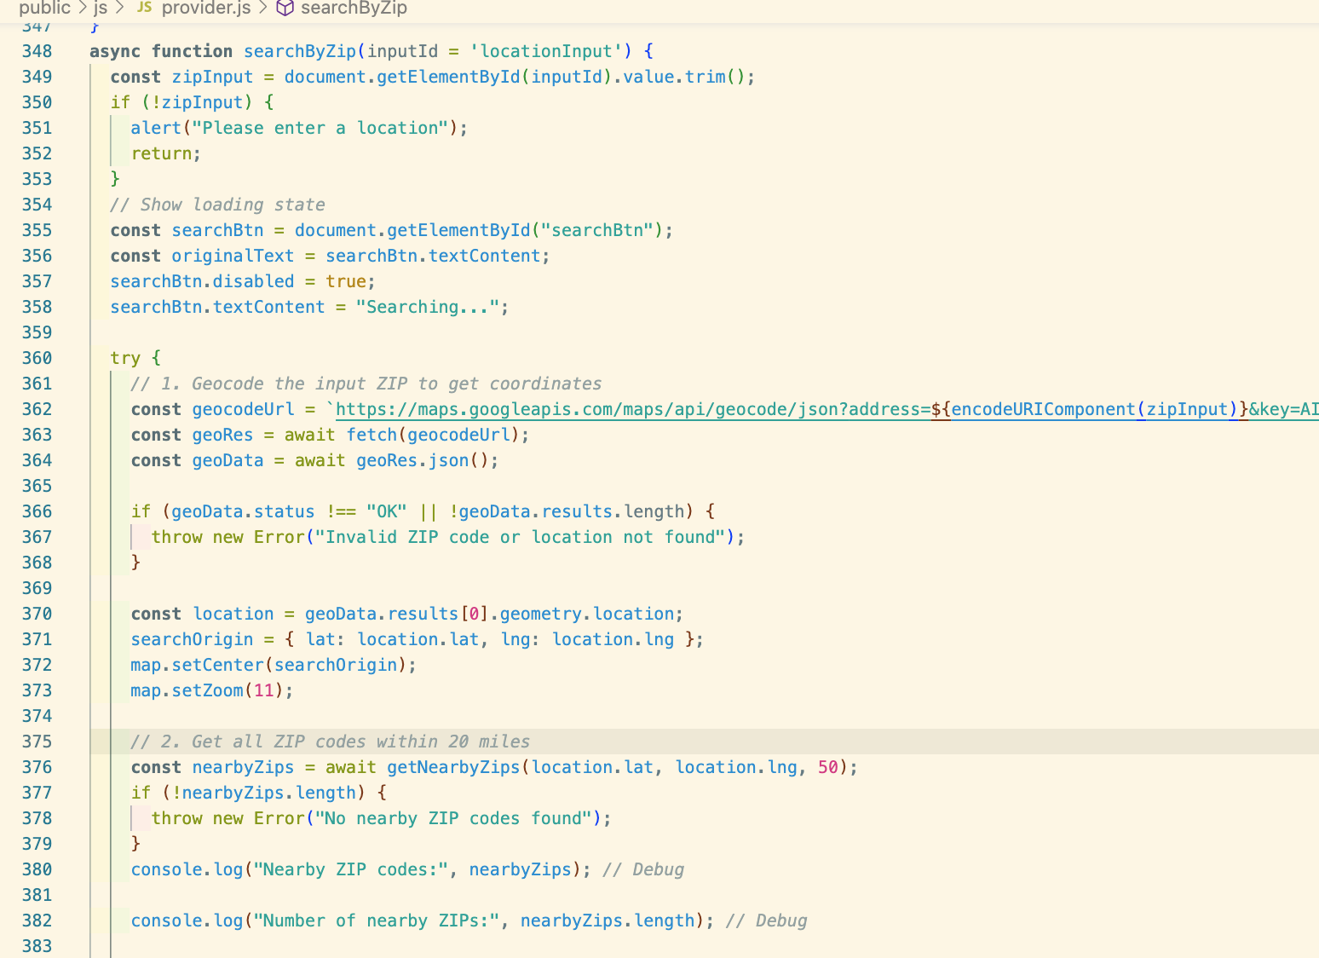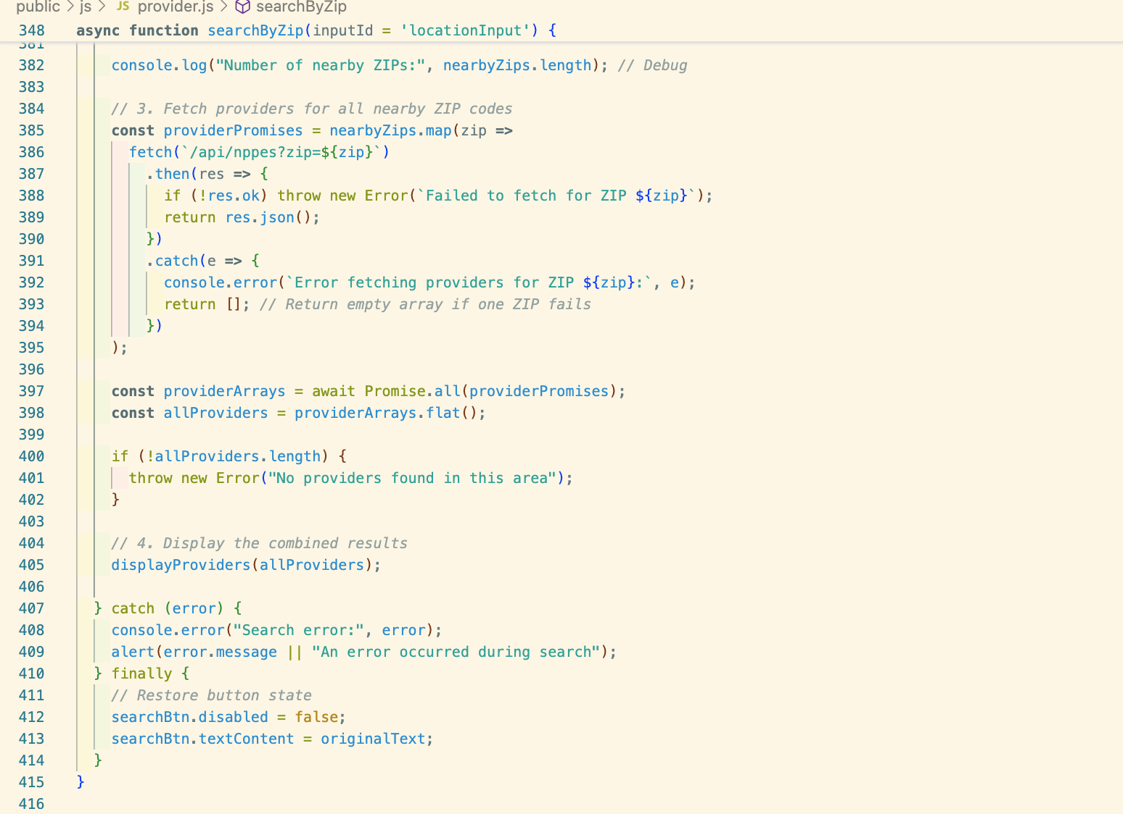

## Nearby ZIP Retrieval with Fallback

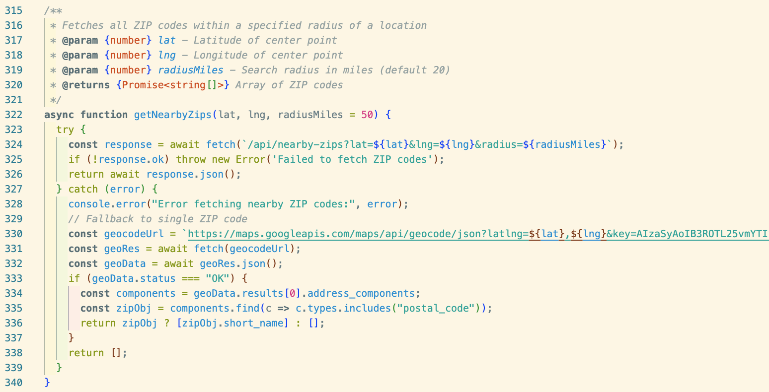

## Marker Interaction on Map

